January 2023
Heritage Shed Restoration

Stage 5 Works to Sheds H and I
We’re onto the final stage of the $30 million restoration of the market’s iconic open-air sheds.
Ten of the market’s 12 historic sheds have already been restored over four stages, securing them as the unique backdrop of the market experience.
The final stage of the project involves the restoration of Sheds H and I. Shed H is the oldest of all the market sheds, believed to date back to the 1850s or 1860s and has a different truss design.
During the shed restoration and to facilitate upcoming market infrastructure works, some fruit, vegetable and organics traders from Sheds H and I will be temporarily located across Queen Street in Sheds C and D. They will remain in this location for approximately three years, while Sheds H and I are utilised for the works nearby.
Follow signage in place to help navigate the market and find your favourite traders.
The works are authorised under Heritage Victoria Permit Number P318866.
From January until mid-2023, onsite works will be undertaken to restore Sheds H and I.
Works include:
Repair and strengthening of structural elements such as trusses
Repair of timber elements
Repair of verandahs
Painting
New insulated roofing to improve the temperature under the sheds
Upgrade of common area services, including power and lighting
Electricity and water to be relocated through service bollards.
Although there are some changes to how you move around the market, all shops and stalls remain open for business.
Thank you for your patience as we undertake these important restoration works.
Work area
Stage 5 includes Sheds H and I, with works occurring Monday to Saturday. Restoration works to Sheds H and I are scheduled from January to mid-2023. The work area will remain in place for the upcoming essential market infrastructure works.
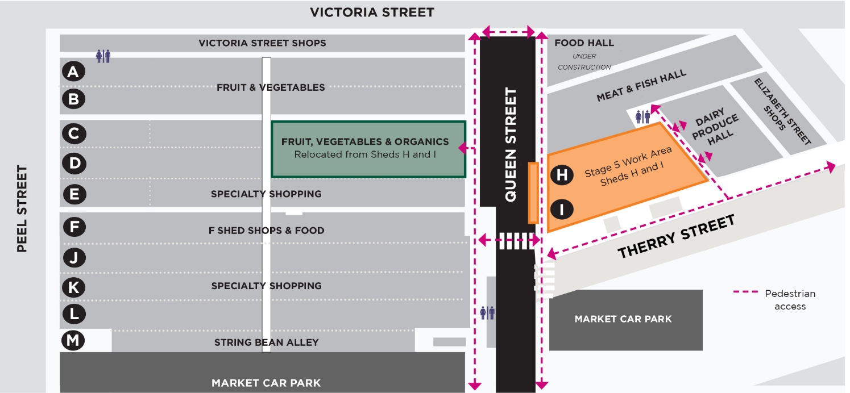
Pedestrian access
The work area will be fenced off, with pedestrian access around the site on Queen and Therry streets. Traders from Sheds H and I have temporarily relocated across Queen Street to Sheds C and D. Please follow signage to help you navigate the lower market, with the Dairy Produce Hall and Meat & Fish Hall open as usual, along with the nearby toilets.
Noise
Works are being undertaken in accordance with WorkSafe and EPA guidelines and are expected to generate low to medium levels of noise. Traders and customers in close proximity to the work area may experience some inconvenience.
Like to know more?
To find out more about the new Food Hall and the Queen Victoria Market Precinct Renewal program, please contact 9658 9658, or visit melbourne.vic.gov.au/qvmrenewal

https://www.melbourne.vic.gov.au/building-and-development/urban-planning/local-area-planning/queen-victoria-market-precinct-renewal-plan/Pages/queen-victoria-market-precinct-renewal-plan.aspx

