Signal Access Key
2024
Getting there

Train: the nearest train station is Flinders St Station.

Tram: the nearest tram stop is Federation Square/Swanston St. This stop is wheelchair accessible.
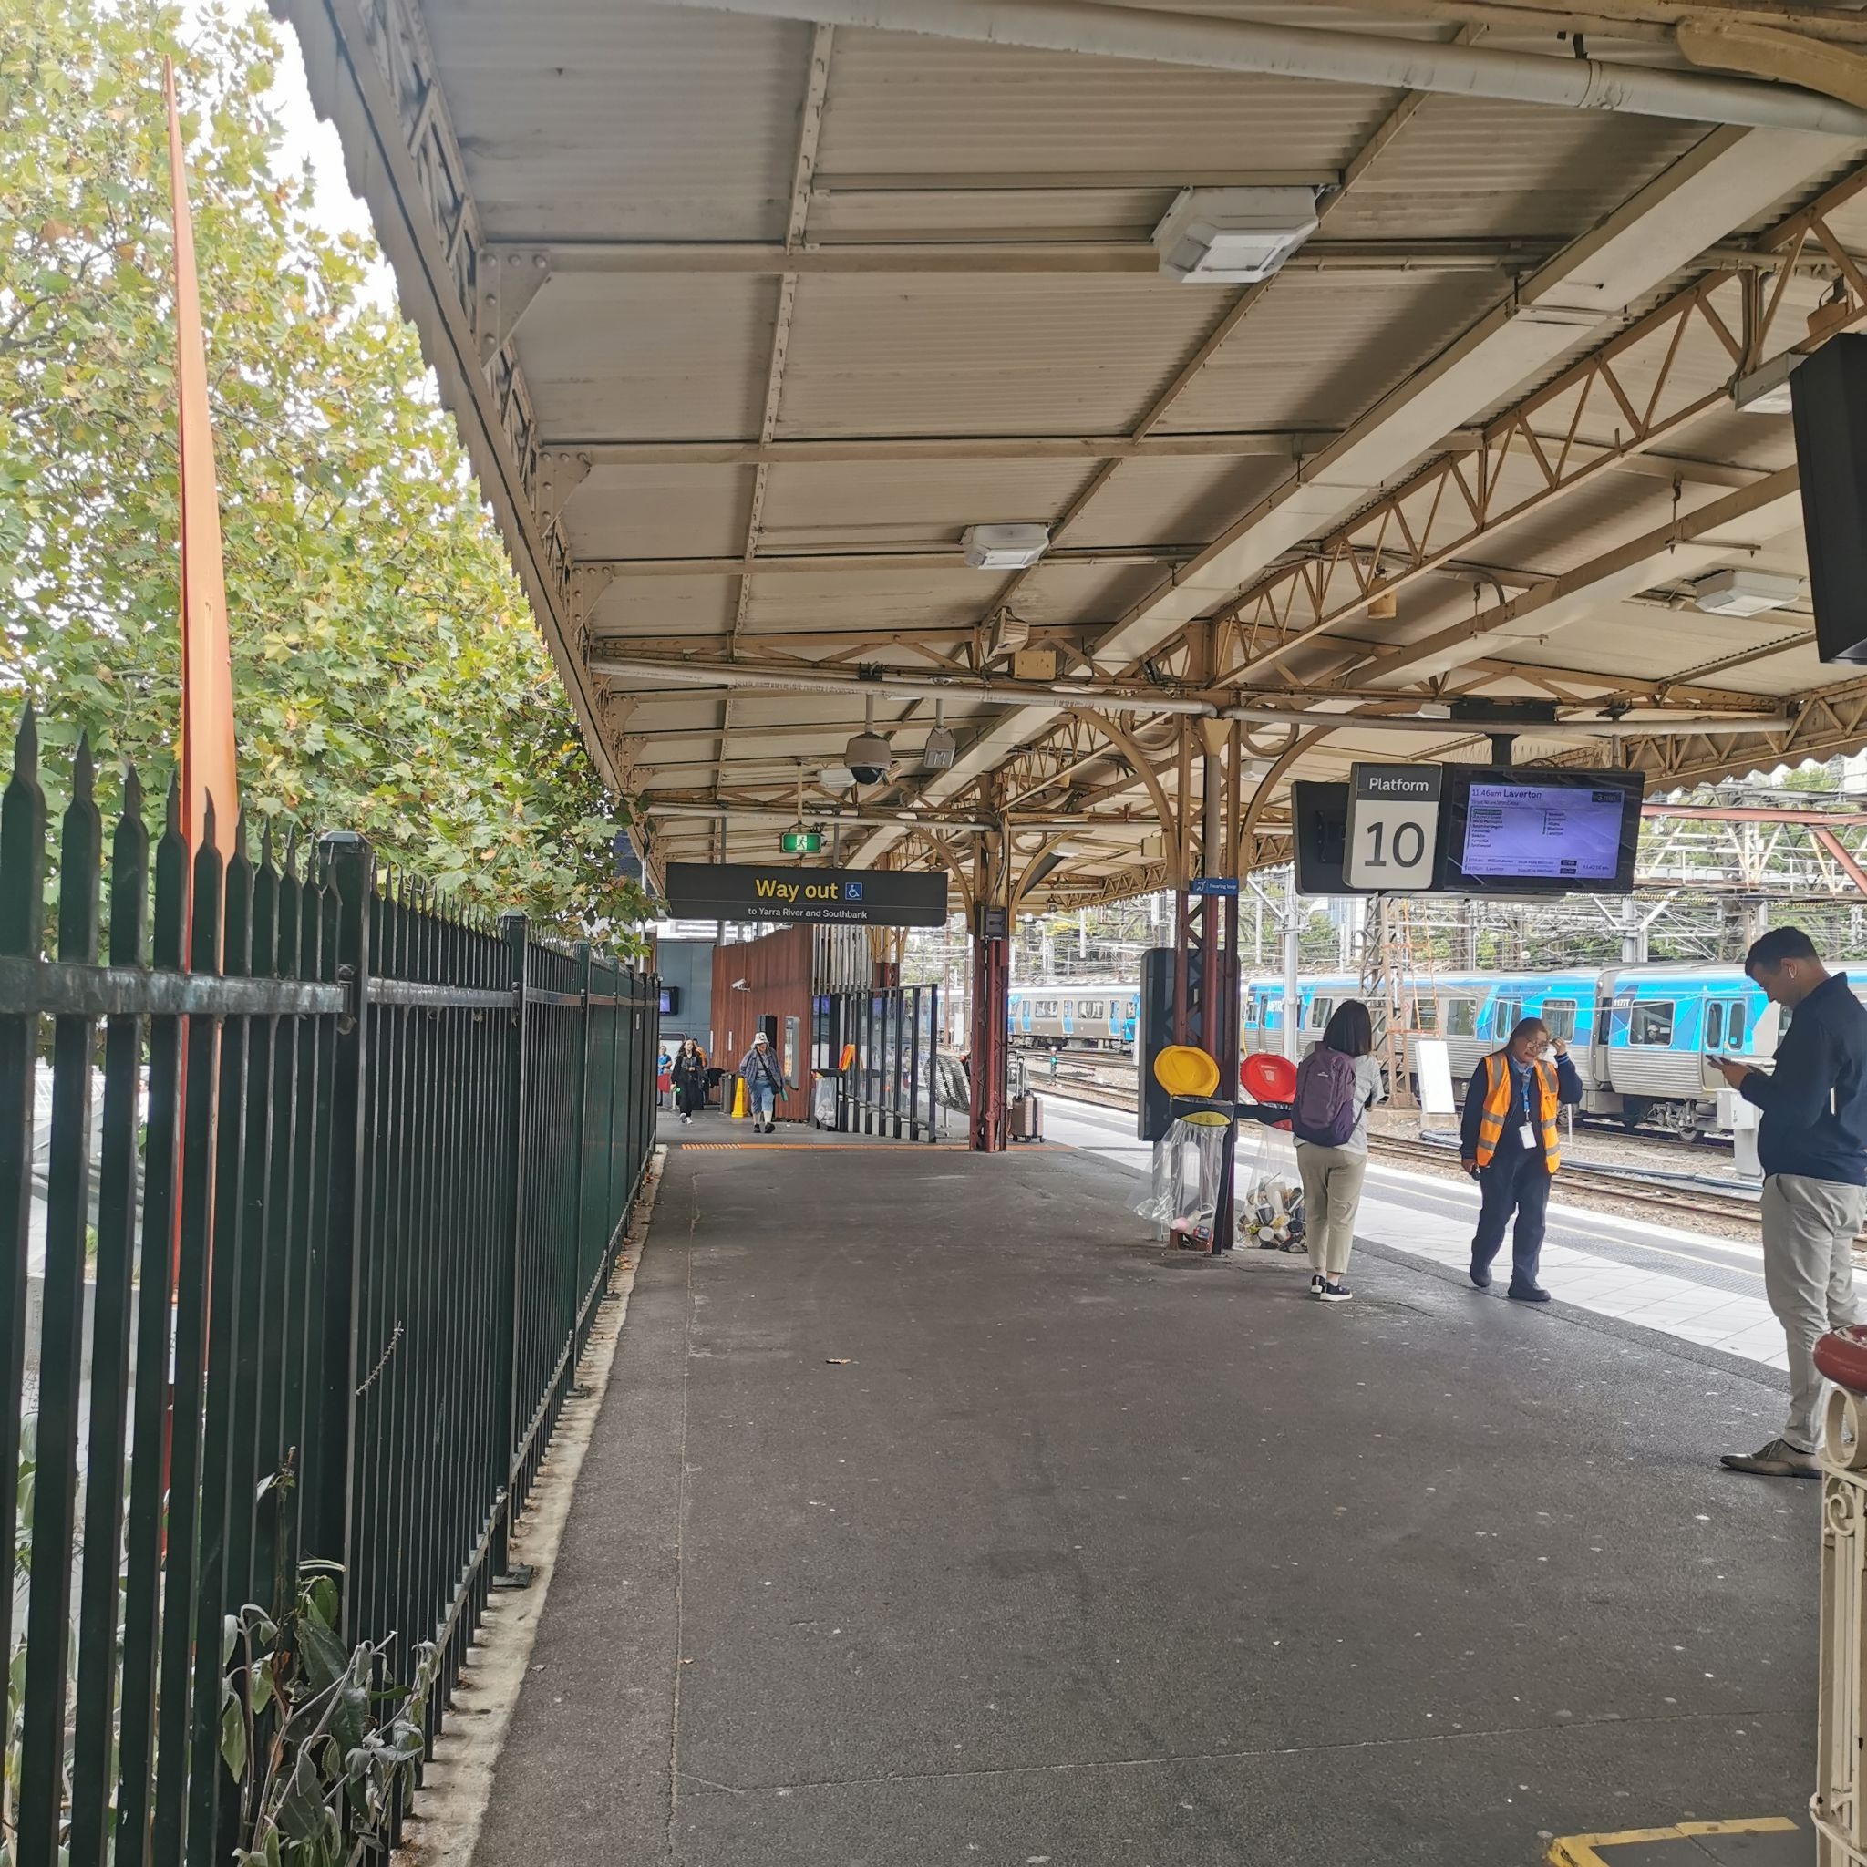
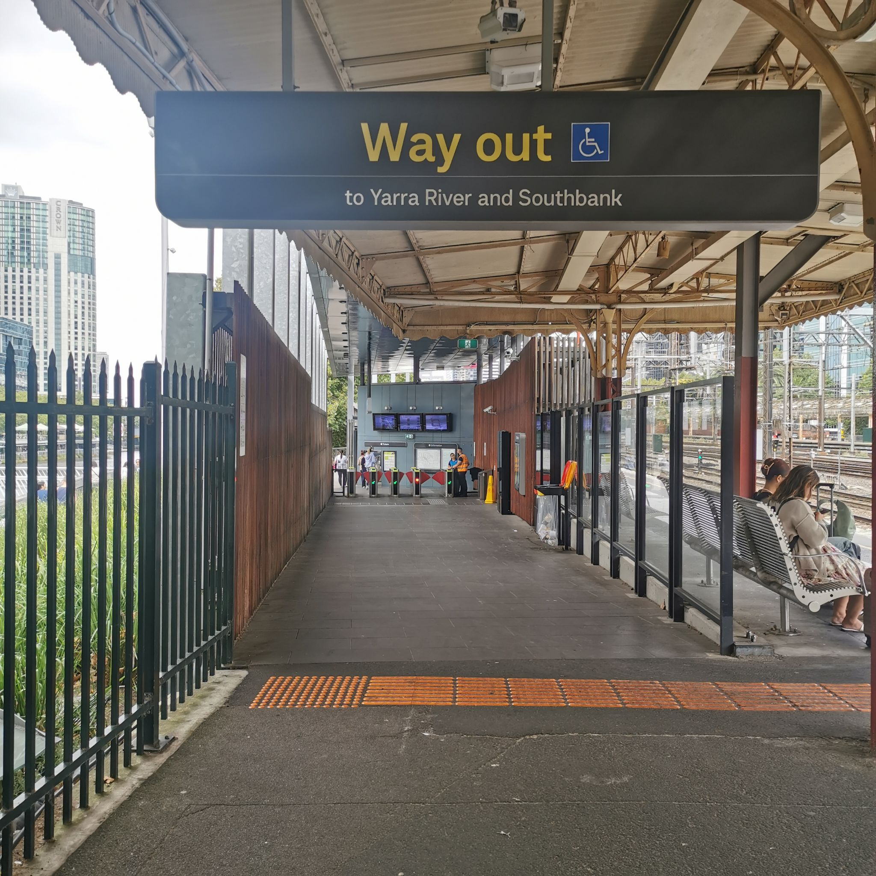
The best way to get from Flinders St Station to Signal is to leave Flinders St Station through the Yarra River Exit/Entrance from Platform 10. There is a lift and an escalator to get onto Platform 10, and the Yarra River Exit/Entrance is step-free.
Heading out of the Yarra River Exit, go straight down Flinders Walk until you see Signal.
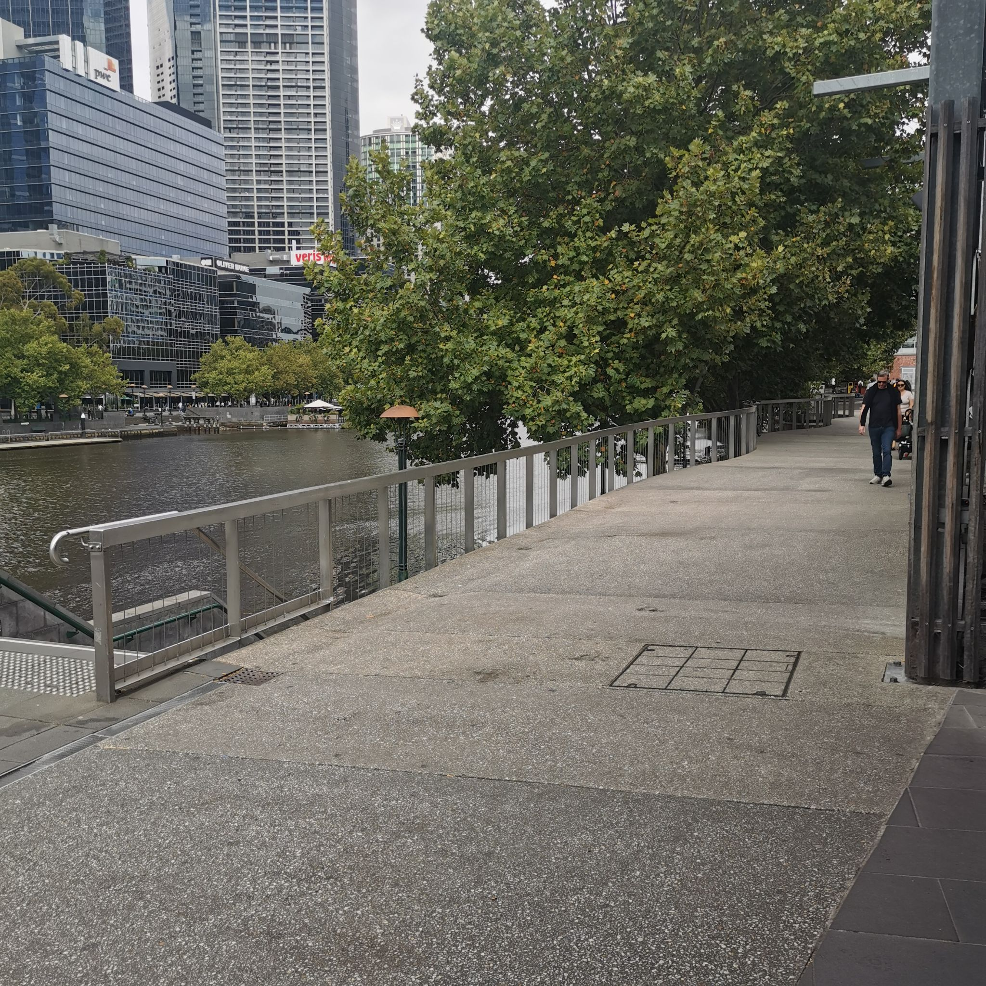

View when exiting Flinders St Station

Google Street View showing the path to Signal
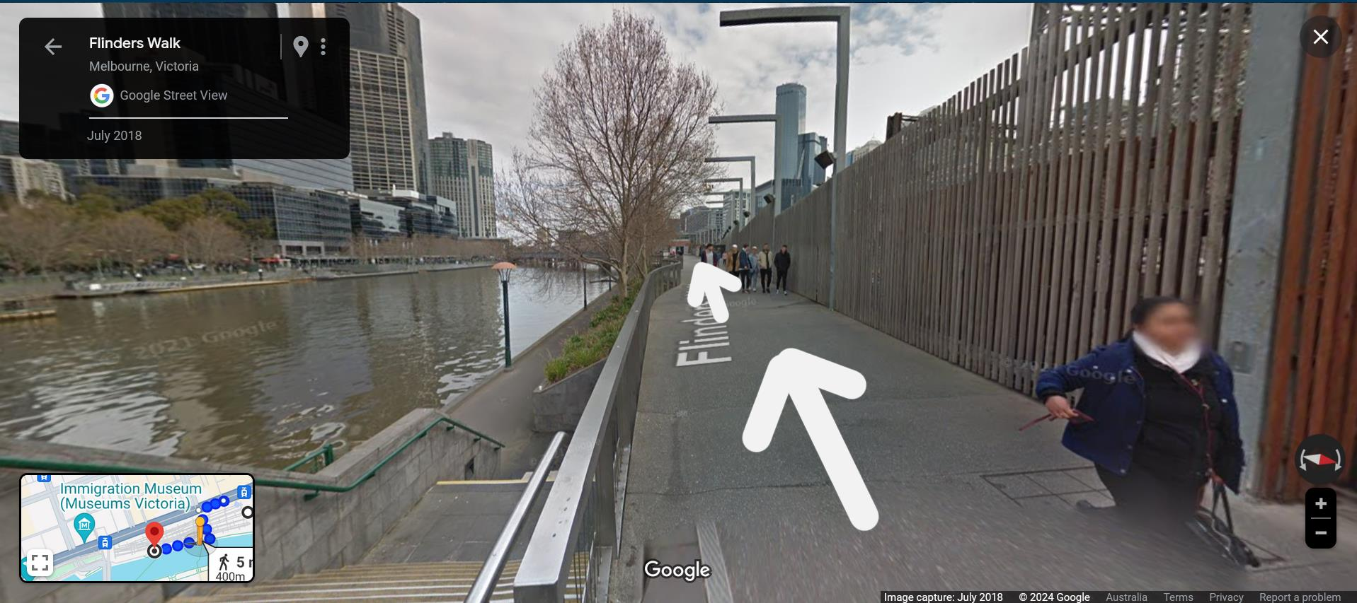

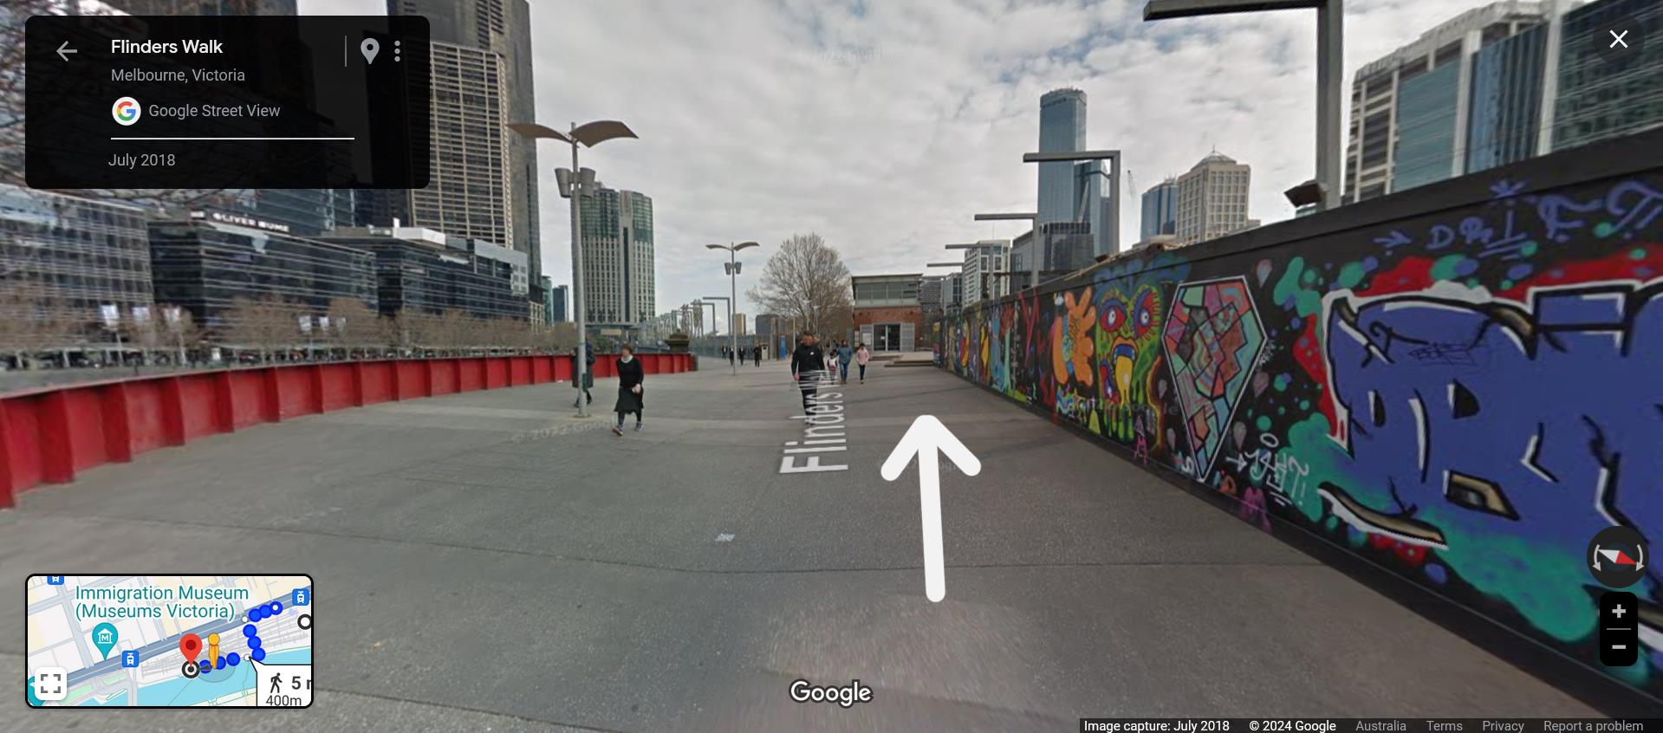

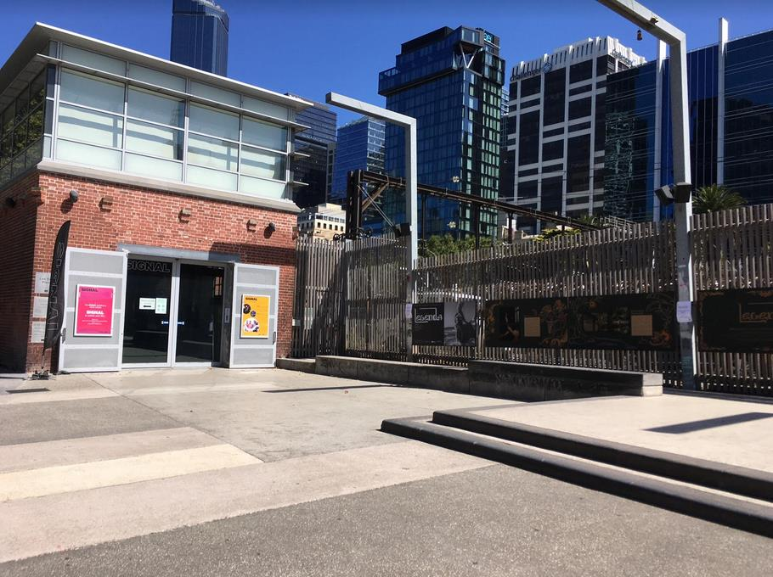

Outdoor area
The outdoor area around Signal is mostly flat concrete, with a long stone bench to the side. There is no shade.

Entry
There are two doors at Signal. If you’re approaching from Flinders St Station you’ll see the doors on the East side first. These are large double glass sliding doors, 267cm wide. This is a step-free entrance.

The second door is on the South side of the building. This is a single sliding door, 96cm wide. This is a step-free entrance.

For most events the east side doors will be closed, and you’ll come in through the south side doors
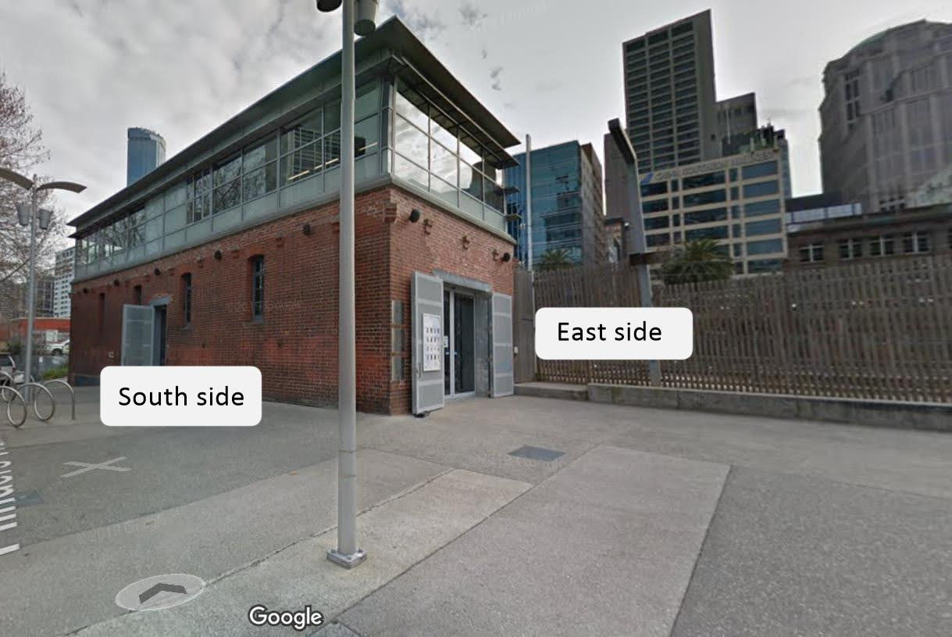

When you come in through the South door there will be a reception desk and corridor to your left, the kitchen directly in front of you, and the large ground-floor event space to your right (see next page for images).
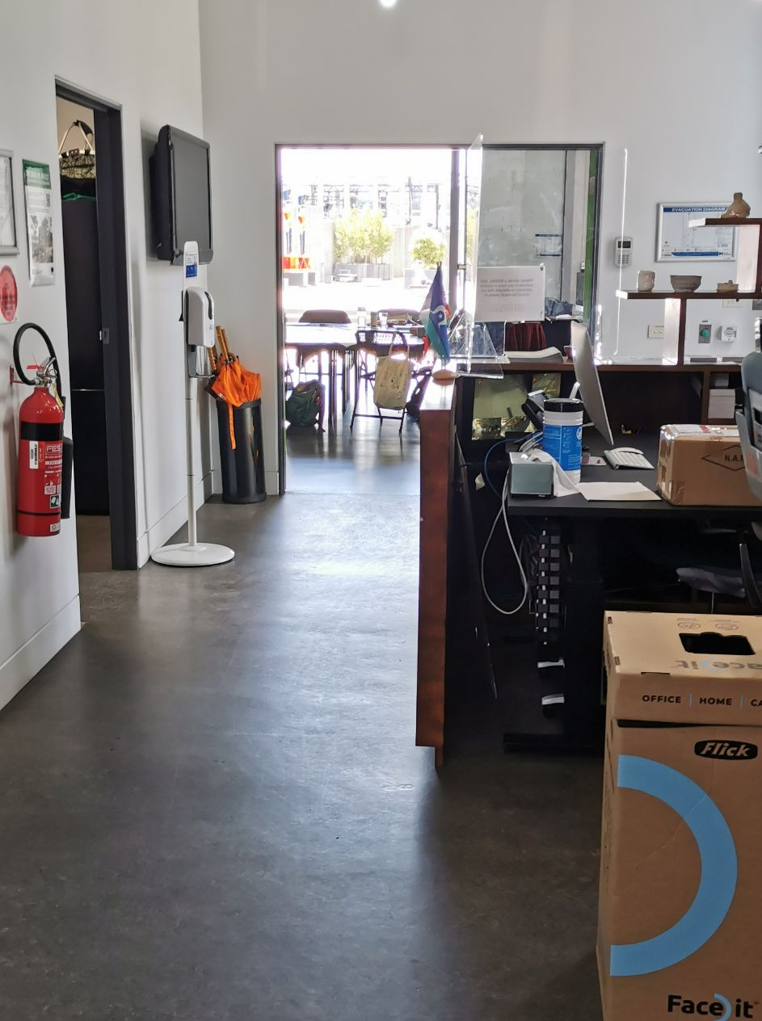
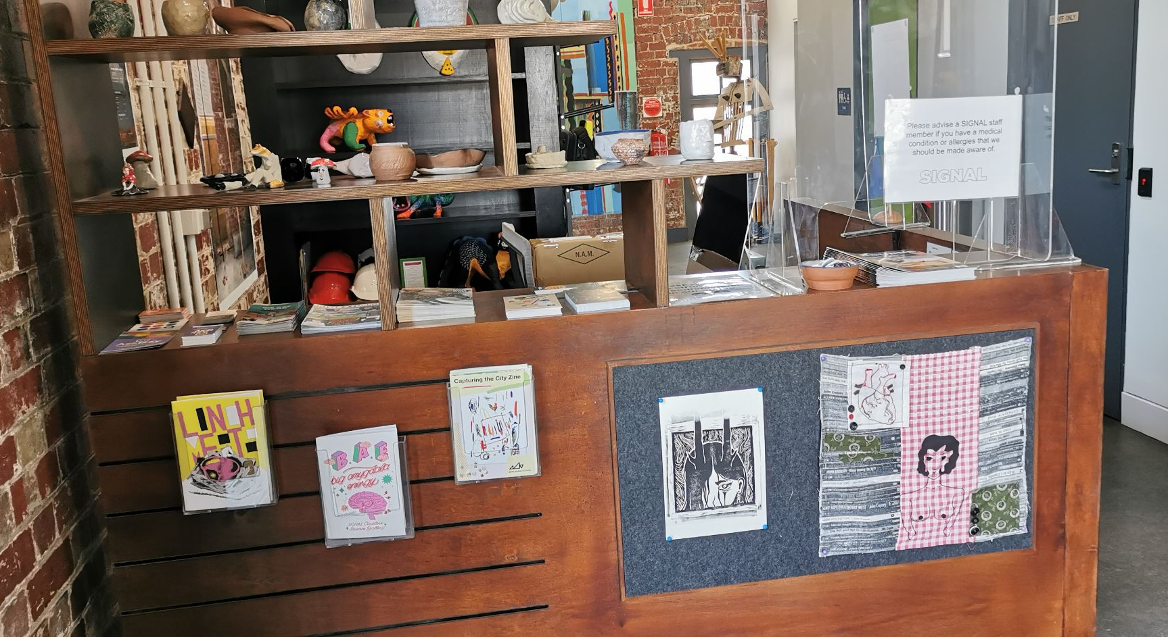
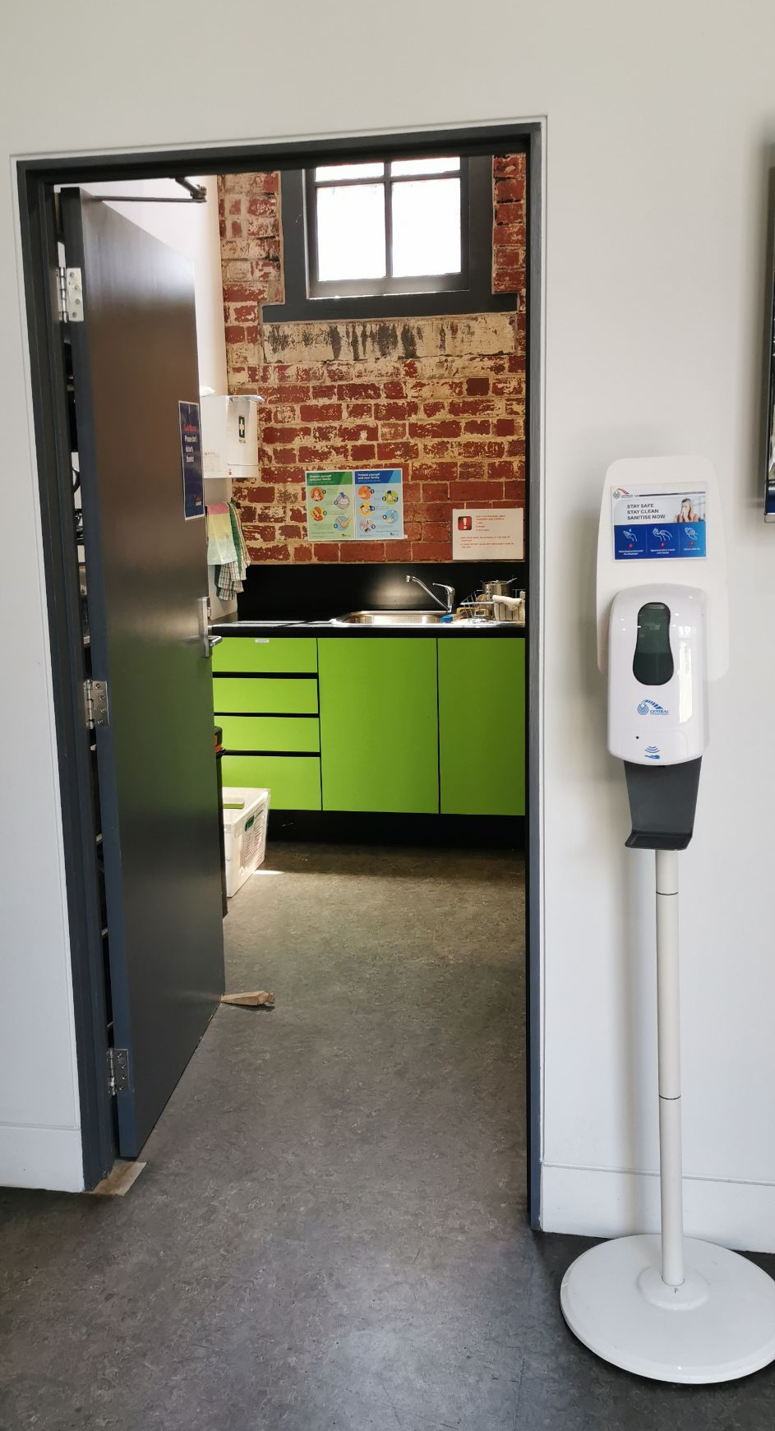
Reception desk
Kitchen

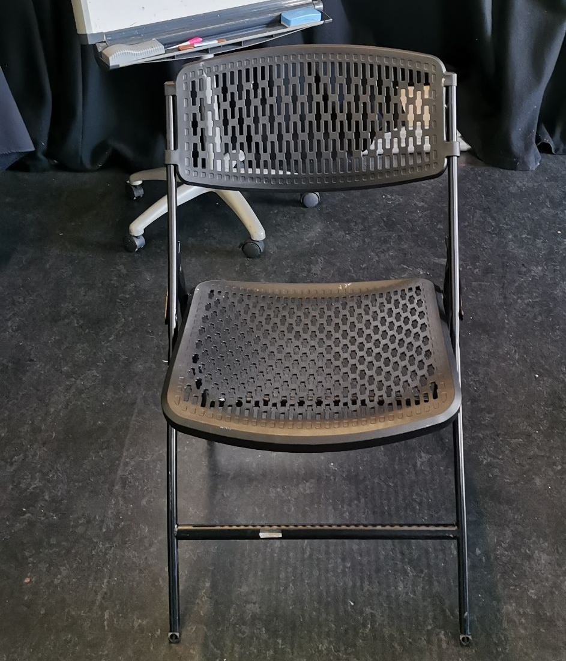
Ground floor event space
You can access the ground floor event space directly through the East side door if it’s open, or come through the South side door and go through the large double doors to your right. All doors are step-free.

The ground floor event space is a large room. This room usually has a few wooden tables in the centre of the room, and there are folding chairs. There is also a projector. There are black floor-to-ceiling curtains along the walls that can be opened or closed.

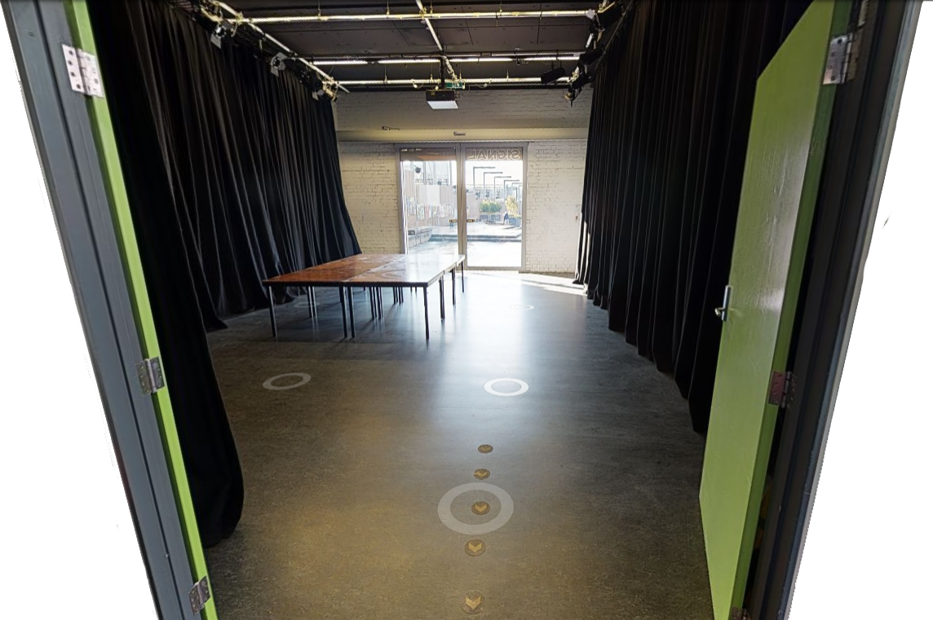

Sensory info
Signal is next to train tracks heading into Flinder St Station, and trains can often be heard going past. There are often people outside, including people skateboarding on the concrete area right outside the East side doors, and they can be loud.

Kitchen
The kitchen is next to the ground-floor event space, directly across from the South side door. The door is 90cm wide.

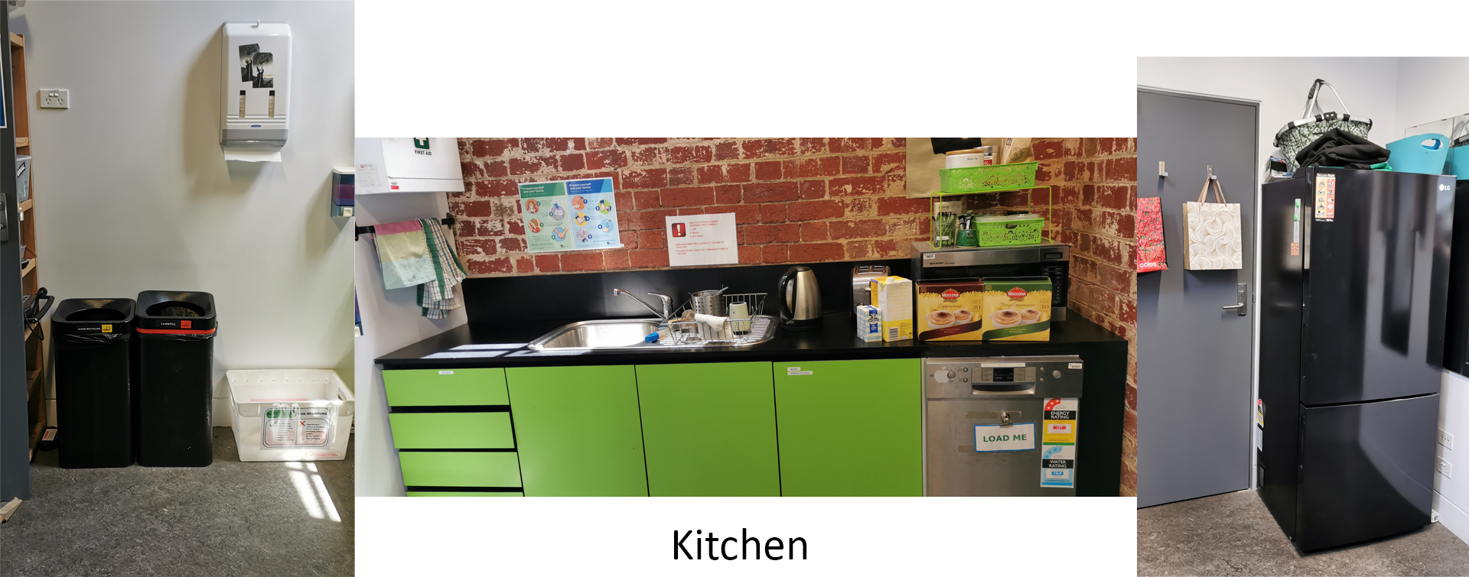
The kitchen has a sink, paper towels, bins, a dishwasher, and a fridge. You can put things in the fridge during events. The sink is 90cm high.

Gender neutral single-stall bathroom
The ground-floor bathroom is next to the kitchen, just past the reception desk. The door is 86cm wide. The bathroom contains a toilet with a grab bar on the wall to the left, a sanitary bin, a sink with soap and paper towels, and an infant changing table (max weight 22kg). There is about 180cm by 290cm of open floor space in the bathroom. The door is manually opened by pushing from the outside or pulling from the inside.
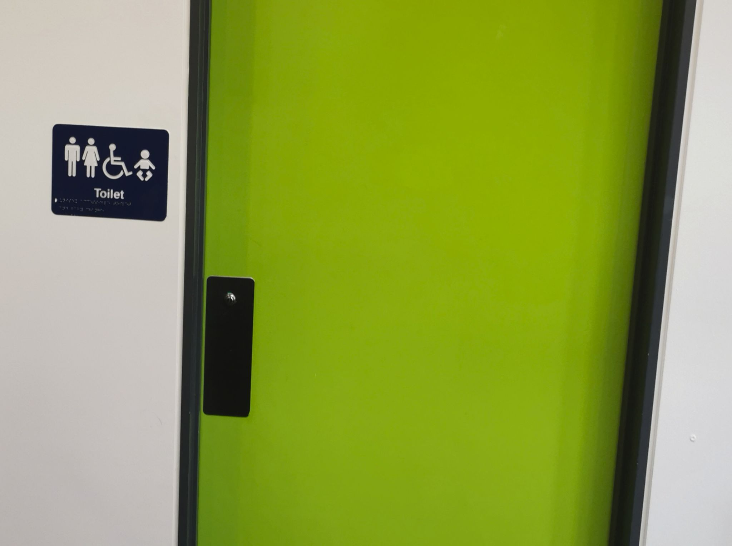

Bathroom door (see next page for photos of the inside)
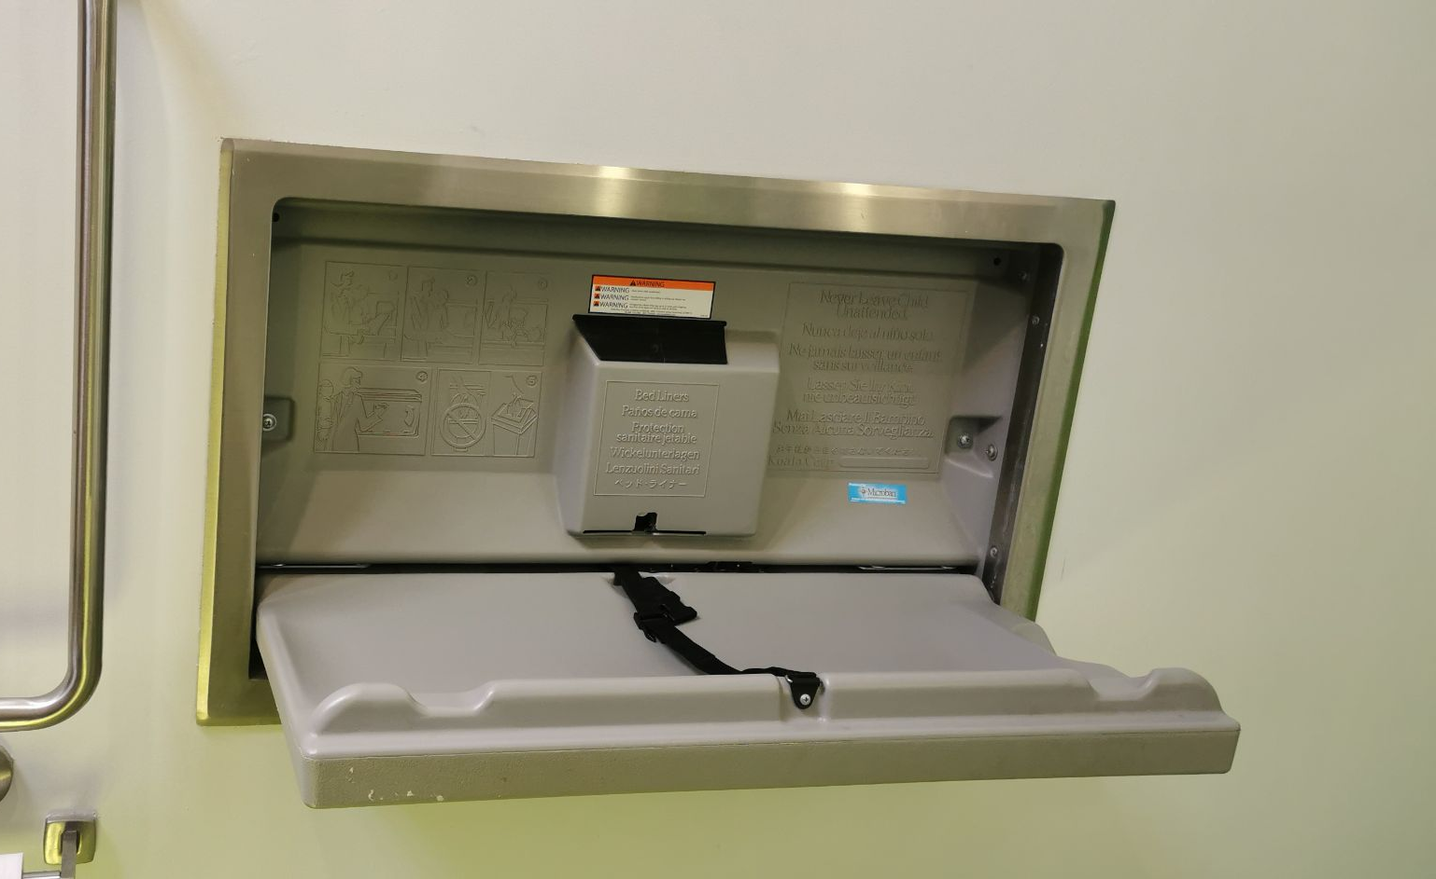
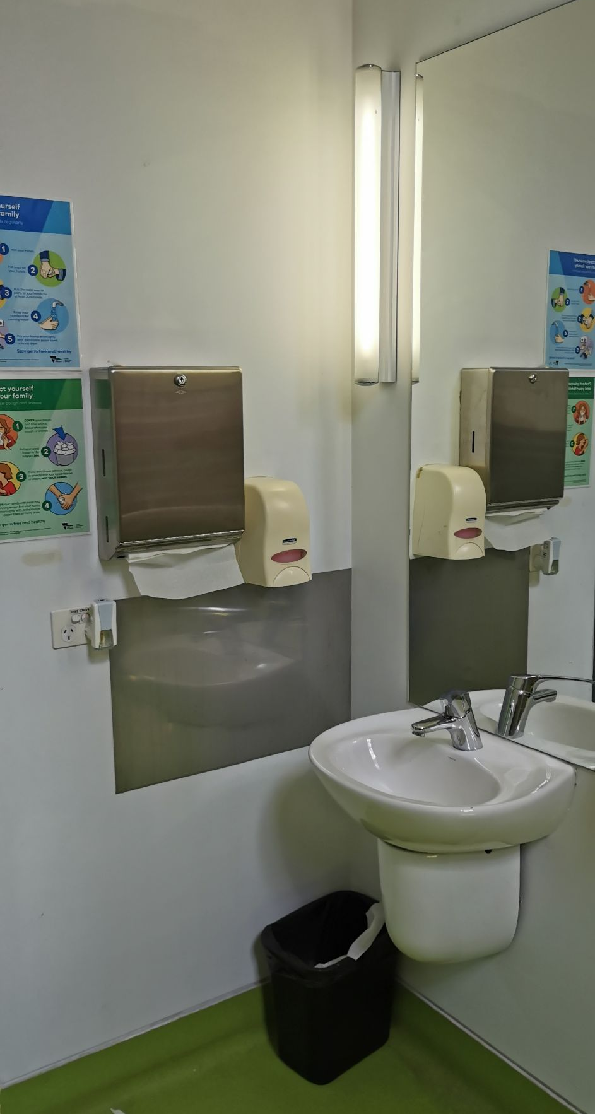
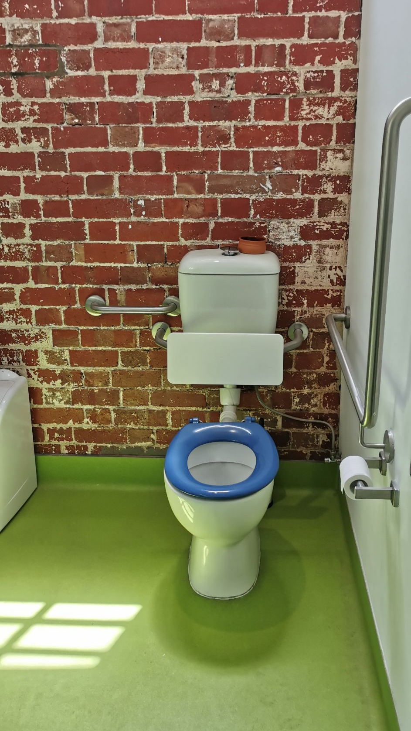

Photos showing the sink, the toilet and grab bar, and infant changing table
First floor
There’s a lift and a staircase to access the first floor. They are both at the end of the corridor, past the reception desk, the kitchen, and the bathroom.

The door to the lift is 90cm wide, and the lift is 140cm by 110cm. The lift buttons are marked with numbers or symbols, and braille.

The stairs have a handrails on both sides and a landing half-way up.
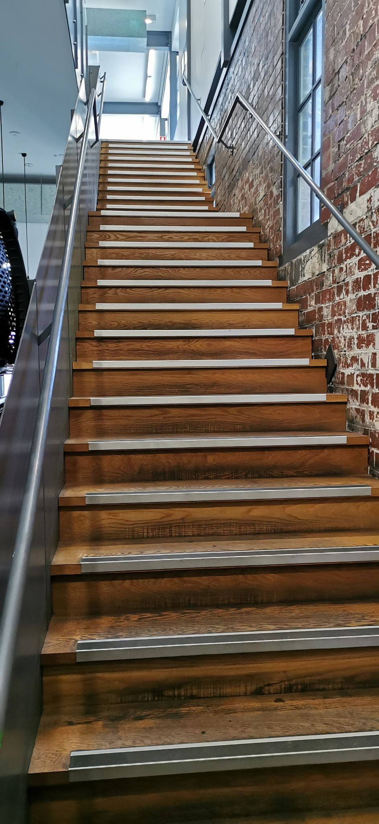
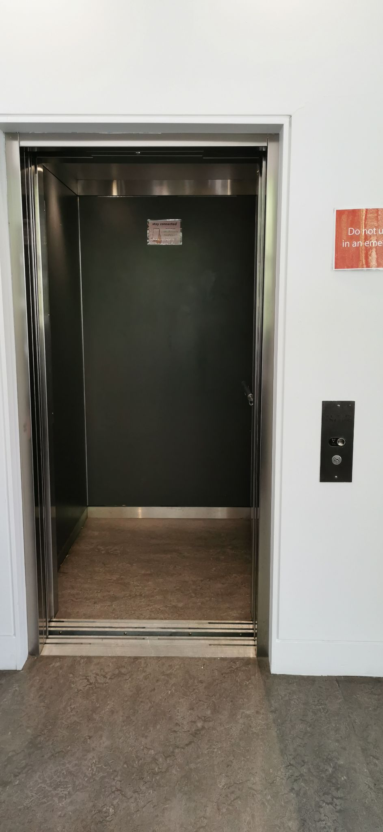

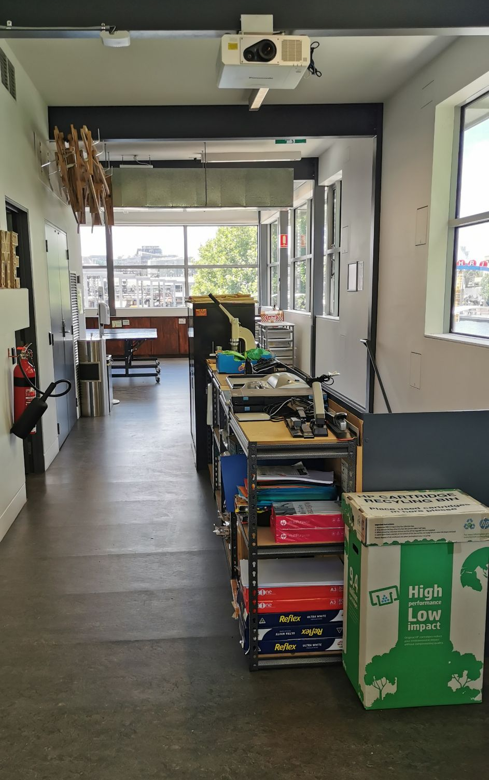
When you exit the lift there is a desk directly across, and a corridor to the left. Go down the corridor and you will pass the first-floor bathroom and reach the first floor event space.

When you come up the stairs the first floor event space is directly in front of you.

First floor single-stall gender neutral bathroom
The first-floor bathroom is just past the lift, towards the open event space. The door is 80cm wide. This bathroom contains a toilet, a sanitary bin, and a sink with paper towels and soap. It does not have grab bars or much open floor space.

First floor event space
The first floor event space is a large open area with a few large wooden tables and folding chairs. There are windows along the three walls, and storage cupboards with art supplies. There’s a sink along the fourth wall.

This room has an HVAC air conditioning system, with heating and cooling. It can be adjusted during events.
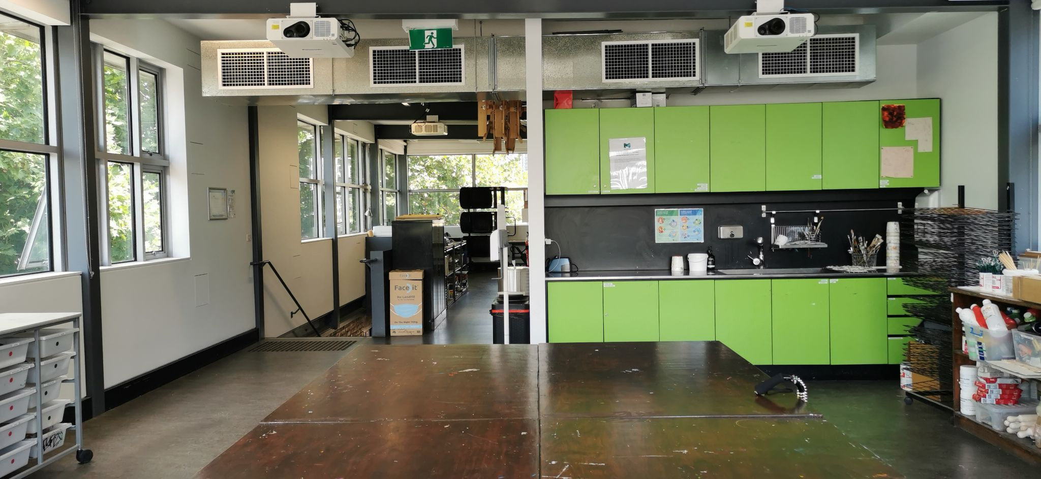
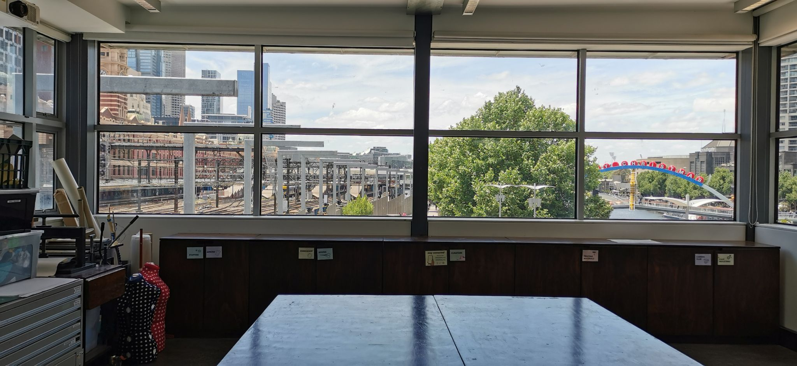
Sensory info
This room is usually bright, lit with natural lighting. Trains can often be heard going past. There may be music during events, which can be adjusted if someone asks- just talk to a support officer.
This Access Key was last updated in March, 2024.

