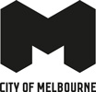
Brunswick Level Crossing Removals Position Paper
Position Paper
Endorsed by the Future Melbourne Committee on 16 May 2023
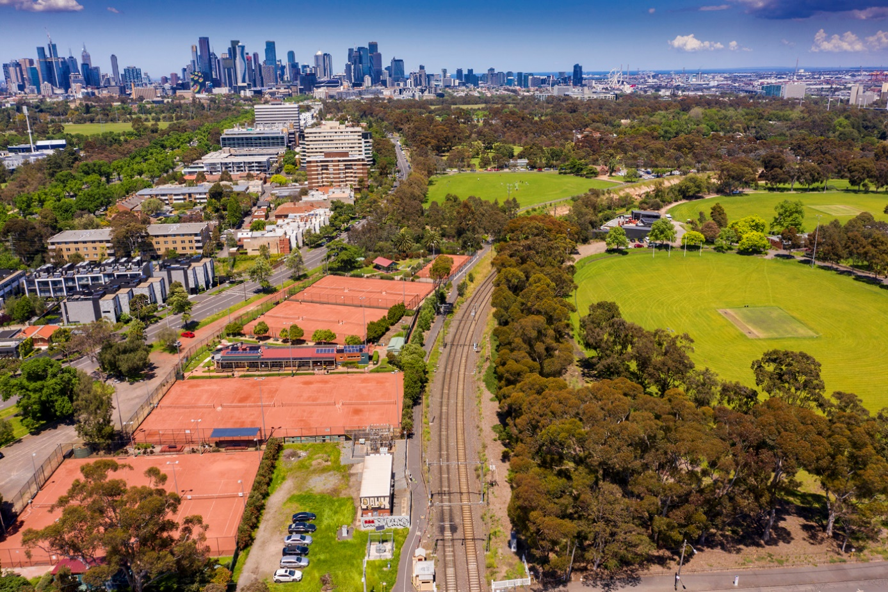

Acknowledgements of Traditional Owners
The City of Melbourne respectfully acknowledges the
Traditional Owners of the land we govern, the Wurundjeri
Woi-wurrung and Bunurong Boon Wurrung peoples of the
Eastern Kulin and pays respect to their Elders past, present
and emerging.
We acknowledge and honour the unbroken spiritual,
cultural and political connection the Wurundjeri, Bunurong,
Dja Dja Wurrung, Taungurung and Wadawurrung peoples
of the Eastern Kulin have to this unique place for more than
2000 generations.
We are committed to our reconciliation journey, because at
its heart, reconciliation is about strengthening relationships
between Aboriginal and non-Aboriginal peoples, for the
benefit of all Victorians.

Contents
1. Executive Summary 4
2. Introduction 6
3. Brunswick Level Crossing Removals Project 7
3.1 Site context 7
3.2 Project timing 10
3.3 Design and construction uncertainty 10
3.4 The City of Melbourne’s role 10
3.5 Merri-bek City Council interface and engagement feedback 11
4. Policy Context 12
4.1 Royal Park Master Plan 1997 12
4.2 Transport Strategy 2030 13
4.3 Nature in the City Strategy 13
4.4 Parks Policy 14
4.5 Other City of Melbourne Strategies and Plans 14
5. Planning Approvals and Environmental Management 15
5.1 Public consultation 15
5.2 Project boundary requirement 15
5.3 Environmental Management Framework 15
5.4 Heritage 16
5.5 Native vegetation and biodiversity impacts 16
6. Management of construction and its impacts 18
6.1 Impacts on Royal Park 18
6.1.1 Active and passive recreation in Royal Park 18
6.1.2 Trees, habitat and biodiversity in Royal Park 19
6.2 Transport networks and parking 21
6.2.1 Enhance existing public transport for rail replacement services 21
6.2.2 Support continued growth in cycling and walking 22
6.2.3 Reduce impacts from construction activity 22
6.2 Environmental and amenity impacts 23
7. Integration of the Project into Royal Park and Surrounds 25
7.1 Improve connectivity within Royal Park 25
7.2 Improved Royal Park northern entrance 27
7.3 Streets and Paths 27
7.4 Urban Design Guidelines 29
7.5 City of Melbourne Design and Construction Management Standards 31

1. Executive Summary
By 2027, the Brunswick Level Crossing Removal Project (LXRP) will have removed eight level crossings on the Upfield railway line. City of Melbourne is a key stakeholder in the project and will work with the Brunswick LXRP team to contribute to the project’s successful planning, design and delivery. This position paper details City of Melbourne’s analysis, requirements and recommendations for project development and our involvement.
Policy context
The main City of Melbourne policies, plans and strategies that apply directly to the project are the Royal Park Master Plan, Transport Strategy 2030, Nature in the City Strategy, and Parks Policy. The Brunswick LXRP team must integrate these into project planning. By the end of 2024, City of Melbourne will complete a review of the Royal Park Master Plan. This revised master plan will be crucial to the development and construction of the LXRP.
Other City of Melbourne strategies and plans that the project team should be familiar with include Urban Forest Strategy, Mapping Aboriginal Melbourne, and the Public Art Framework.
Management of construction and its impacts
The Brunswick LXRP team should prepare an Environmental Management Framework (EMF). The project EMF must be prepared in consultation with City of Melbourne.
Royal Park is the largest open space in the City of Melbourne. There are significant mature trees along the western boundary of the rail corridor adjacent to Park Street. Every effort must be made to retain and protect all trees within Royal Park from any construction activity that may impact their health and/or longevity.
Royal Park and the rail line cutting are both significant for Melbourne’s biodiversity. The park is home to extensive areas of native and indigenous vegetation including open woodland with trees, grassland, and wetland habitats. Important and/or rare species of flora and fauna may exist there; the project must investigate before works begin.
There are several sports facilities located within Royal Park, including the Royal Park Golf Course, the Royal Park Tennis Club, several sporting ovals and pavilions. The enjoyment and ability of all active and passive recreation to continue during construction needs to be considered by the Brunswick LXRP team. Any proposed occupation of areas within Royal Park must be avoided.
Transport management will be a crucial component of the Brunswick LXRP and presents significant opportunity to improve transport within and through the project area into the future. At a policy and strategic level, City of Melbourne prioritises walking, public transport and cycling. We encourage the Brunswick LXRP team to work with us to ensure this opportunity is taken full advantage of for the good of the city.
For example, during rail line occupations, City of Melbourne suggests moving away from the usual approach of using rail replacement busses and instead augmenting existing public transport to maintain connectivity. Investing in existing public transport services by improving priority, accessibility and frequency of services will deliver broader long-term benefits. Furthermore, improved bike and pedestrian facilities delivered prior to the major disruption are required to provide safe alternatives for the Upfield shared use path.
In addition to transport management, the Brunswick LXRP team will need to develop plans to manage and mitigate the impacts of construction on the environment and amenity. Plans may include dust, noise and vibration, lighting, stormwater contamination, and contaminated land.
Construction of major projects puts pressure on local roads through increased demand for parking, increased truck movements and local traffic diversions. Impacts such as noise, dust and safety of vulnerable road users will need to be managed through thoughtful and detailed construction and workforce planning. Heavy vehicles will likely damage local road surfacing, which the Brunswick LXRP team will need to repair as if left unrepaired, the damage will create safety hazards and increase dust and noise pollution.
Integration of the project into Royal Park and surrounds
Royal Park is a significant, complex part of planning for the Brunswick LXRP: it services many user groups, has several access points, and substantial interaction with the rail line, which traverses it. The park hosts several sporting activities and sportsgrounds, informal recreational spaces including a dog park, and three ovals with various structures.
City of Melbourne recommends that the project design:
- allows for a link across the Upfield railway line in accordance with the Royal Park Master Plan
- minimises the size and height of structures
- reduces the clearance over Park Street
- reduces the number of structures above the rail track
- reduces the visual impact of the viaduct, structural pillars and embankments by using soft landscaping and planting to screen the railway
- upgrades any shared paths impacted by the project to encourage and support increased active transport, ensuring safety of pedestrians on shared paths, including the Capital City Trail
- tells the story of Aboriginal Cultural Heritage and the Wurundjeri Woi-wurrung and Bunurong Boom Wurrung peoples of the Eastern Kulin as Traditional Owners of the land
- creates a safer and more inviting northern Royal Park entrance with improved shared path connections
- results in no loss of parkland
- considers graffiti-preventative strategies
- retains heritage features of the Upfield railway line, including gates and gatekeeper’s cabin.
Conclusion
The disruption of the Brunswick LXRP presents many challenges and opportunities for the project team, local councils, transport users, and the local community. City of Melbourne looks forward to working with the project team towards the best outcomes for all.

2. Introduction
In September 2022, the Victorian Government announced plans to remove eight level crossings on the Upfield railway line, between Park Street, Parkville in the south and Albion Street, Brunswick in the north by elevating the train line on a new rail bridge. The new rail bridge will connect to the recently completed rail bridge from Bell Street to Moreland Road.
Seven of these identified crossings are entirely within Merri-bek City Council. Park Street, Parkville is on the municipal boundary between Merri-bek City Council and City of Melbourne.
The Level Crossing Removals Project (LXRP) will build an elevated rail bridge using concrete and steel beams called a viaduct that will continue into Royal Park, removing the existing train line and boom gates on Park Street. It is anticipated that the new rail track will remain within the existing railway corridor and tie into the existing track before Royal Park Station.
Public announcements regarding the project confirm that the Victorian Government plans to:
- deliver the project through the LXRP team
- deliver improvements to the Upfield shared use path, including separating the bike and pedestrian paths from Bell Street to Park Street
- create “around four MCGs’ worth” of open space between Parkville and Coburg
- undertake community consultation on the project once further concept design and engineering assessments are completed
- complete the project by 2027.
The Brunswick LXRP is in the very early stages of project design, with much unknown about the detailed design and the specifics of how the project will be delivered. Unknowns include:
- the height of the rail bridge over Park Street (from Bell Street to Moreland Road, the height of the rail bridge varies along the corridor; however, a minimum clearance of 5.5 m from the ground level to the bottom of the rail bridge was achieved)
- how, where and at what gradient the rail line emerges from the existing cutting in Royal Park
- the engineering details and design of the rail bridge and its concrete pylons
- the construction methodology and resultant impacts.
With this in mind, City of Melbourne has identified several issues, requirements and opportunities that will be progressed as the project design and delivery evolves. Given the uncertainty of the design and delivery, it is important to consider that the position as presented in this paper will likely evolve over time as more information is known.
The issues and opportunities identified in this paper have been formulated based on our team’s professional knowledge of similar projects, experience of the design and construction of other projects completed by LXRP, and engagement with stakeholders.

3. Brunswick Level Crossing Removals Project

3.1 Site context
The Brunswick LXRP will build an elevated rail bridge over Park Street, removing the existing train line and boom gates. The rail bridge will continue into Royal Park where it will gradually decline and tie in with the existing track.
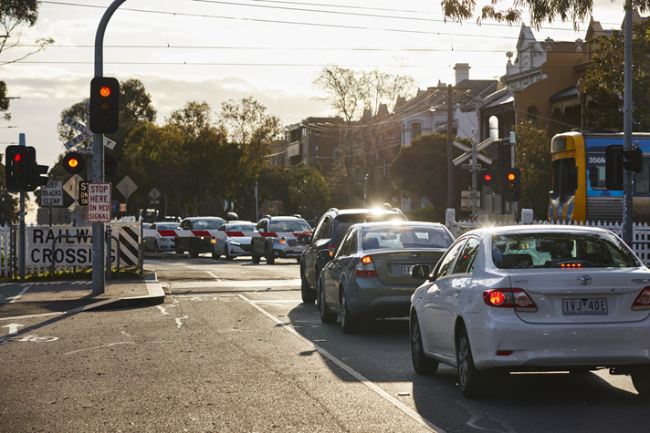
Photo 1 Existing Condition Park Street, Parkville (Source: LXRP)
Royal Park is the largest open space in the City of Melbourne, covering 170 hectares. It is protected under the Victorian Heritage Register. Its vast treed native vegetation landscape is an oasis on the edge of the city. There are significant mature trees along the western boundary of the rail corridor adjacent to Park Street.
Royal Park is situated on land of importance to the people of the Eastern Kulin Nation. The park is also historically significant as it was the starting point of Burke and Wills' ill-fated expedition to the Gulf of Carpentaria in 1860 and the site of the Acclimatisation Society of Victoria in 1861, part of which later became the Royal Melbourne Zoological Gardens.
Royal Park is the most biodiverse park in the City of Melbourne and the most popular for birdwatchers. Threatened species such as the nationally endangered swift parrot (Lathamus discolor) are regularly recorded in the park.
The park is Crown Land, permanently reserved for use as a public park and City of Melbourne is responsible for its management.
The Upfield railway line runs through Royal Park, servicing the Royal Park train station. The line is in a deep cutting before meeting Park Street to the north at grade.
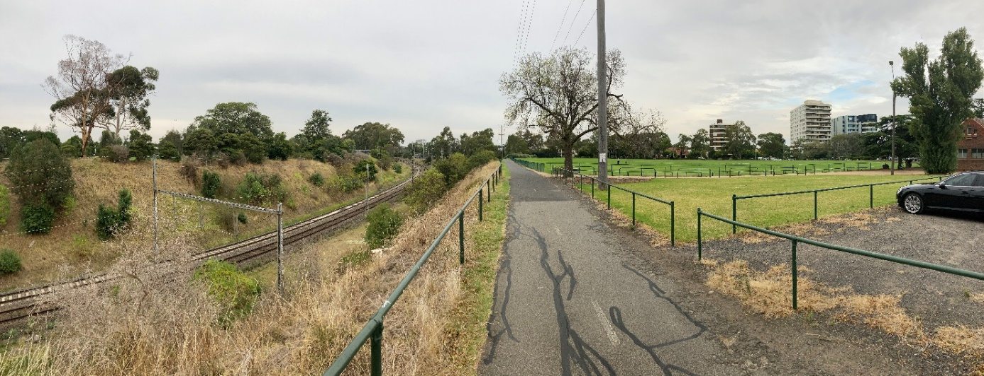
Photo 2 Upfield rail line in a deep cutting before near Poplar Oval, looking northeast
Tram route 58 also runs north–south through Royal Park with tram stop 27 before Poplar Road and near Royal Park train station and bus stops for Route 505. The Department of Transport and Planning (DTP) is exploring opportunities to provide safer, more connected journeys around the Royal Park Station Precinct, with the aim of making it easier and safer for passengers, pedestrians, bike riders and road users to move through the area, attend local attractions and interchange between transport modes.
The Upfield shared use path, a path for cyclists and pedestrians that follows the Upfield rail line through the inner northern suburbs, crosses Park Street and enters Royal Park from the north. The southern end of the Upfield path connects to the Capital City Trail to the south of the Royal Park Tennis Club. Cyclists can join the Royal Parade bike path and on road bike lane at Park Street.
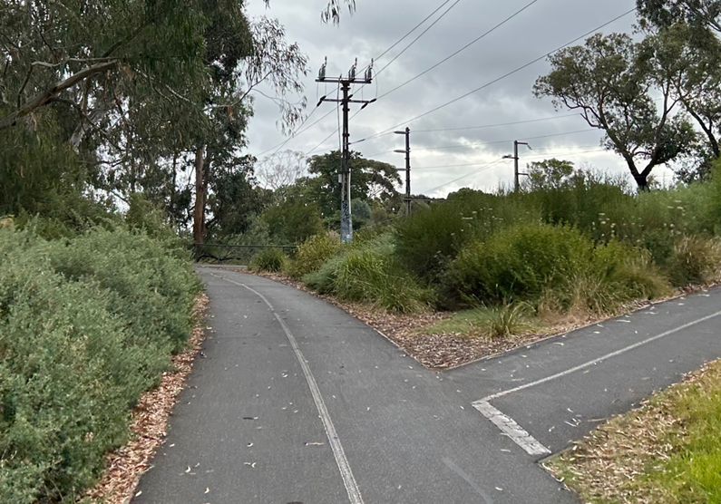
Photo 3 Capital City Trail junction with the Upfield Shared path, looking towards the railway
- The Victorian Heritage Register states that the Upfield railway line precinct’s “railway structures, which includes stations, gatekeepers' cabins and gates, signalling equipment and a footbridge provide remarkably intact evidence of the technology and architecture of a late 19th and early 20th century railway system.” It also states that the railway structures “retain elements now rare or unique within the metropolitan area.”
The Park Street Gatekeeper’s Cabin (including the awning and lever frame) and the gates (including sector gates, pedestrian gates and their associated closing mechanism, rodding extending to the gatekeeper’s cabin and the associated picket fencing) are all protected.
Due to the age of the railway, there is a high chance of historically important indigenous plant species existing on the railway cutting of the Upfield railway line where services began in 1884. The cutting itself has important geological features.
Park Street is a local road shared with Merri-bek City Council. It has one traffic lane in each direction and a service carriageway on its northern side to serve local properties in Brunswick. There is kerbside parking along the edge of Royal Park and within the service carriageway. It currently has painted bike lanes adjacent to the kerbside parking and service carriageway. This has been identified as a future protected bike route in the 2030 Transport Strategy.
There are several sports facilities located within Royal Park, including the Royal Park Golf Course and the Royal Park Tennis Club. The Royal Park Tennis Club offers day and night access to 14 courts. They have lights facing towards the immediate east of the railway line.
The Royal Park Golf Course is a nine-hole public golf course with the Upfield railway line bisecting it. The clubhouse is located across the railway line from most of the fairways. The golf course is the largest single sports facility in Royal Park.
There are three sporting fields to the west of the railway line in the area known as Royal Park north. These fields, McAlister, Ryder and Ransford ovals, are all supported by the Ryder and Western Pavilions and are used by 10 different groups participating in six different organised sports all year round. They are also used daily as a dog off-leash area and recreation reserve. The northern area serves several informal recreational usages including cricket practice nets, individual private exercise and dog walking.
The City of Melbourne Parks Depot, including the main vehicle washdown bay, is also located in this part of the park.
To the east of Royal Park is The Avenue, a predominantly residential area.
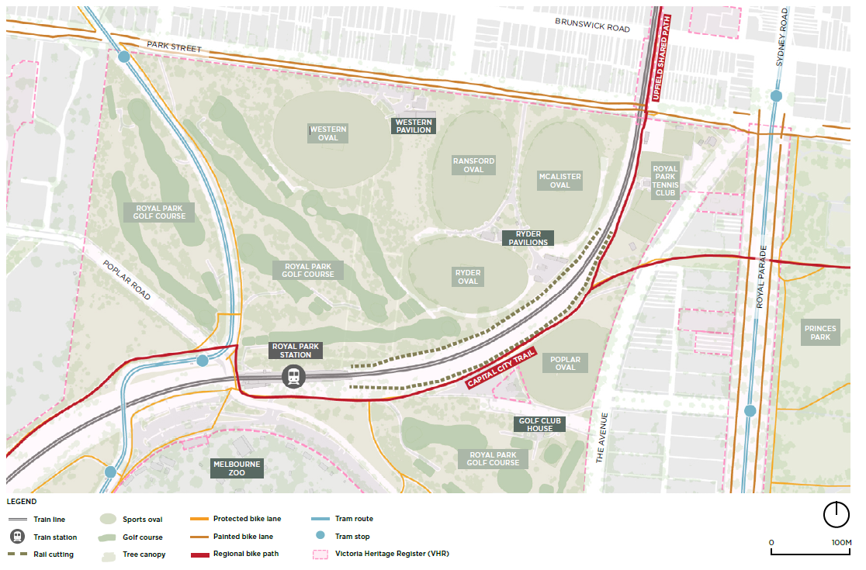
Figure 1 LXRP site context within City of Melbourne

3.2 Project timing
The steps for removing a level crossing are:
- early site investigations, which are currently underway
- concept design and initial community consultation, which is expected to be completed in the second half of 2023
- a refined design based on community feedback including the City of Melbourne
- a final design
- work to remove the level crossing
- completion of the project in 2027

3.3 Design and construction uncertainty
As the project is in the very early stages of design, City of Melbourne has made assumptions including:
- An elevated rail viaduct will be made from prefabricated concrete u-trough beams on concrete pylons to replicate the design of the elevated railway from Bell Street to Moreland Road.
- Clearance over Park Street will be less than 5.5 m.
- The new elevated railway will be contained within the existing rail corridor land in Royal Park. There will be no widening or further trenching of the cutting and no occupation of further parkland required at the completion of the project.
- Park Street will remain open to all traffic after completion of the project.
- City of Melbourne will be responsible for the management and maintenance of non-rail public assets delivered as part of the project on land managed by City of Melbourne.
- Potential construction laydown sites outside of the rail corridor land are currently unknown. The rail land is not wide enough to accommodate sufficient areas to service the delivery of the project.
- Limited works can be completed before the main occupation due to the narrow width of the rail corridor. Early works will include service relocations and other preparatory works completed on various extended weekend shuts of local road and the railway.
- Impacts on existing vegetation and trees are currently unknown.
- The main construction will be undertaken during a long closure of the Upfield railway line under an occupation scenario. Works could be operating all hours, every day to minimise the length of time the line is closed.
- Bus replacement for rail services is usually provided during a rail occupation.
- The Upfield shared use path will need to be closed for the duration of the main construction. The experience during the Bell Street and Moreland Road works was that the path was closed longer than the railway to complete landscape works.

3.4 The City of Melbourne’s role
Level Crossing Removal Projects are funded, planned and delivered by the Victorian State Government via the Level Crossing Removal Project (LXRP).
The City of Melbourne is a key stakeholder in the projects as we have an important role advocating on behalf of our community and working with project teams to minimise construction impacts. We are also seeking to influence the design to ensure the values of Royal Park are maintained and enhanced in line with the Royal Park Master Plan.
Councils are typically asked to take over the management and maintenance of new non-rail assets when they are constructed on Council managed land. City of Melbourne therefore needs to ensure that these assets meet our standards.

3.5 Merri-bek City Council interface and engagement feedback
Of the level crossings identified to be removed in the Brunswick LXRP, seven are entirely within Merri-bek City Council. The centre of the Park Street Road reservation forms the municipal boundary between Merri-bek City Council and City of Melbourne.
Following the Victorian Government’s announcement, Merri-bek City Council (Merri bek) publicly expressed its support for the project. Merri-bek undertook its own engagement program between December 2022 and March 2023 because of the impact the project will have on Brunswick and high levels of local interest.
Outcomes of Merri-bek's engagement program demonstrated a high level of agreement between different groups about what was most important to consider on the project. The Reshaping Brunswick Report presented to Merri-bek on 12 April 2023 states that:
examples of sentiments that recurred throughout included: the need for good, clear, early information on the project; transparency of decision making; a desire for community involvement in the design process; a level of support given to those who will be most impacted through delivery of the project, especially those living next to the rail line and those with mobility issues; an aspiration that pedestrians and cyclists are prioritised; and concerns about the potential bulk of new infrastructure and its impact on homes, businesses, trees, heritage, and sunlight.
Key findings of stakeholder engagement on issues within the City of Melbourne include:
- how, where and at what gradient the rail line emerges from the existing cutting and how this impacts part of Royal Park
- Royal Park should experience minimal impacts
- queries on whether Park Street will need to be closed due to the gradient of the rail line from Royal Park
- how the trees and landscaping within the project area will be impacted by project construction and concerns for their protection
- how the project presents opportunities for improving cycling connectivity between the Upfield shared use path, the Capital City Trail and Royal Parade
- there is an opportunity to improve the blind corner at the intersection of the Upfield shared use path and the Capital City Trail in Royal Park
- there is an opportunity to improving cyclist safety on southbound Park Street and Royal Parade as there is no separation of cyclists and motorised vehicles
- the lighting in the Capital City Trail underpass at Royal Parade should be kept on during the day to improve visibility and safety
- the Park Street Gatekeepers Cabin obstructs cyclists' views along the Upfield shared use path
- the heritage boom gates and Gatekeepers Cabin should be restored and become a feature in any new design.

4. Policy Context

4.1 Royal Park Master Plan 1997
The City of Melbourne developed a master plan for Royal Park in 1997. The Royal Park Master Plan has guided decision making in the park over the past 25 years. The inclusion of the park on the Victorian Heritage Register in 2014 has also guided management of important heritage elements in the park.
The City of Melbourne is reviewing the Royal Park Master Plan 1997. The review is being coordinated by our Parks and City Greening branch who are currently in the first year of a two-year process. A revised master plan is due for completion in July 2024.
A lot has changed since 1997 including social, cultural and environmental changes that have had an impact on Melbourne. This needs to be reflected in the new Master Plan, which should consider:
- The Aboriginal Cultural Heritage and the Wurundjeri Woi-wurrung Cultural Heritage Aboriginal Corporation as Registered Aboriginal Party (RAP) should be acknowledged for the whole of Royal Park.
- The Commonwealth Games in 2006 created land use change and increased residential population adjacent to the park (Parkville Gardens).
- The Open Space Strategy in 2012 identified the need for new play spaces to service the increasing residential population catchments around Royal Park.
- Royal Park’s inclusion on the Victorian Heritage Register in 2014.
- Impacts on Royal Park by fragmentation from road, rail and tram networks.
- Nature in the City Strategy 2017 elucidates that Royal Park is the most biodiverse park in the city and it needs to be protected and this status enhanced.
- Social and recreational visitors should be accommodated due to current and proposed population growth.
- The park should do more for people, without impacting environmental services, as it provides a canopy, cooling and species habitat.
- The 1997 Masterplan has actions that have not been accomplished due to feasibility, funding and support for key projects.
The first year involves undertaking several specialist background studies to inform the master plan revision. These studies are due for completion by June 2023 and will be subject to public consultation in late 2023 or in 2024.
These studies include:
- A Conservation Management Plan providing an extensive history of the park including cultural values from the Wurundjeri Woi-wurrung Cultural Heritage Aboriginal Corporation as the RAP for Royal Park.
- A sports participation needs assessment will provide an understanding of the community’s current and future sport and recreation needs for Royal Park.
- An ecological gap assessment will identify current information on the ecology within the park and the gaps requiring further investigation.
- A parking management plan will provide a holistic view of the parking within and around Royal Park and make recommendations on future parking management for the park.
- A safety audit is reviewing 10 hot spots in the park where safety has been identified as a key concern. The safety audit will provide guidance on improving the issues at these sites.

4.2 Transport Strategy 2030
The Transport Strategy 2030 sets a target of 70 per cent of all trips in the municipality being made by public transport, walking and cycling by 2030, as well as a 50 per cent reduction in fatalities and injuries on streets within the municipality. The removal of level crossings on the Upfield railway line provides an opportunity to support these targets, as well as other outcomes of the Transport Strategy 2030.
Outcome 9 of the Transport Strategy 2030 covers the City of Melbourne’s high-level positions on major transport projects. Where new projects are proposed, we seek to ensure they will support increased use of public and active transport rather than private motor vehicle use.
We will seek to work with the Victorian Government to take advantage of the behaviour changes associated with major disruption to prioritise use of sustainable transport and deliver improved infrastructure and road space reallocation for people using public and active transport. Rather than reverting to original road and traffic conditions once construction is complete, City of Melbourne’s preference is to take the opportunity to make improvements to sustainable and active modes of transport. Major disruptions such as the Brunswick LXRP create the opportunity to turn temporary changes in travel habits into permanent ones.
The City of Melbourne supports a transition to a turn-up-and-go public transport network (Outcome 8.2), which means frequencies of at least 10 minutes from 6am to 12am every day. The Upfield railway line currently does not provide a turn-up-and-go service, even during peak hours, but the removal of level crossings presents an opportunity for a service uplift.
Safety improvements for people riding bikes and using micromobility is central to the Transport Strategy 2030 (Outcomes 2.1, 2.2 and 2.3) and should be considered a high priority given the opportunity presented by major works on the rail corridor. Intersection and road crossing designs should prioritise sustainable modes of transport as well as the safety, efficiency and amenity of these modes.
With the removal of the level crossings it will be important to optimise traffic signals to ensure that users of the Upfield shared use path are not unnecessarily delayed, as per Outcome 5.1. In addition, Outcome 8.6 supports the integration of bikes and micromobility into the public transport network. This includes high quality connections to stations and stops, suitable end-of-trip facilities, and allowing bikes onto replacement bus services.

4.3 Nature in the City Strategy
The City of Melbourne’s Nature in the City Strategy, which was endorsed in 2017, aims to create and maintain healthy ecosystems and thriving biodiversity within the city.
The strategy has three goals and six priorities that will guide the next 10 years of planning, development, and management of the city’s biodiversity and ecosystems. It also provides details on a set of actions and targets to evaluate the success of their implementation.
In considering our city as a wider ecosystem the project presents the opportunity to actively foster connections amongst people, plants, animals and the landscape. By protecting and enhancing biodiversity in the city, we can create a legacy of a resilient, balanced and healthy natural environment, which serves a community that is connected to nature and enjoys the associated benefits to health and wellbeing.

4.4 Parks Policy
The Parks Policy sets out our vision for the city’s parkland and establishes guidelines for their effective management. It aims to meet the needs and expectations of all those use our parklands, while ensuring the quality and beauty of Melbourne's green spaces are preserved for future generations.
Key aspects of the policy include an assurance that there will be no net reduction in parkland area, and provision for continuing community involvement in the planning of parks, and informing stakeholders prior to major projects commencing.

4.5 Other City of Melbourne Strategies and Plans
Other City of Melbourne strategies, frameworks and plans of relevance to the project include:
- Urban Forest Strategy
- Parkville Urban Forest Precinct Plan 2015–2025
- Open Space Strategy
- Mapping Aboriginal Melbourne
- Public Art Framework
- Public Lighting Strategy.

5. Planning Approvals and Environmental Management
It is expected that the Brunswick LXRP will be declared under the Major Transport Projects Facilitation Act 2009 (the MTPFA), which removes the application of local laws and other Council statutory controls and approvals processes.
Clause 52.03 of the Melbourne Planning Scheme provides specific planning requirements for the Brunswick LXRP. The Clause removes the need for separate Planning Scheme Amendments or planning permits for each level crossing removal project provided the requirements of the Clause are met.

5.1 Public consultation
Clause 52.03–04 of the Melbourne Planning Scheme requires that before the commencement of the project, public consultation is conducted including consultations with the relevant municipal council(s) and a consultation summary report is prepared submitted to the Minister for Planning. This mandatory pre-commencement requirement cannot be varied or waived by the Minister for Planning.
Community consultation by the project team, is a critical element of project planning. Extensive and effective engagement that works with all stakeholders from the very early stages of the project is essential. Stakeholders include City of Melbourne, Royal Park sporting groups, community groups, and residents.
City of Melbourne will provide additional formal feedback on the project as part of this process.
Requirement
- Engagement with local communities and stakeholders should be undertaken from the very early stages of the project to draw on local insights, values and knowledge to inform the planning, design and delivery of the project.

5.2 Project boundary requirement
Clause 52.03 also specifies a project boundary requirement prior to the commencement of the project construction. It specifically requires a plan that shows the boundary of the land area where works will occur.
This is a mandatory pre-commencement requirement and cannot be varied or waived by the Minister for Planning.
Requirement
- Consultation with the City of Melbourne on the project land boundary should occur prior to its gazettal.

5.3 Environmental Management Framework
An Environmental Management Framework (EMF), prepared in consultation with each relevant municipal council is required before the project commences and should include:
- a summary of key construction methodologies
- an overarching framework of measures to reduce and manage environmental and amenity effects during construction
- a summary of performance monitoring and reporting processes, including auditing, to ensure environmental and amenity effects are reduced and managed during construction
- a summary of how each relevant municipal council, the community and other stakeholders will be engaged during construction, including enquiries and complaints management.
A summary of the consultation with each council that informs the EMF can also be presented to the Minister to inform their assessment.
The provision of an EMF however is not mandatory and can be varied or waived by the Minister for Planning.
City of Melbourne welcomes this requirement of Clause 52.03 and looks forward to working with the Brunswick LXRP project team in the development of the EMF regarding the measures to reduce and manage environmental and amenity effects during construction of the project.
Requirement
- Given the significant impact of the project on areas including Royal Park, the local road and cycling network, and residential properties, the Minister for Planning should require the LXRP project team to prepare the EMF in consultation with City of Melbourne in accordance with Clause 52.03 of the Melbourne Planning Scheme.

5.4 Heritage
While the project boundary has not been declared, City of Melbourne notes that the Upfield railway line runs through several portions of land that are subject to Heritage Overlays (HOs) under the Melbourne Planning Scheme. This includes HO4 (Parkville Precinct) and HO1093 (Royal Park, Flemington Road and Royal Parade and Gatehouse Street and The Avenue and Elliott Avenue and Park Street and Poplar Road and Macarthur Road and Oak Street and Brens Drive, Parkville).
Clause 52.03–06 specifies that if affected land is within a HO, the following is required:
- a report that addresses the impact of that development on the heritage significance of the heritage place
- site plans and elevations showing the extent of that development on the land.
We note that the above requirement is not mandatory and can be varied or waived by the Minister for Planning.
Requirement
- A report, including site plans and elevations, that addresses the impact of the development on the heritage significance of the heritage place, particularly Royal Park, in accordance with Clause 52.03 of the Melbourne Planning Scheme is considered necessary and should not be varied or waived by the Minister for Planning.

5.5 Native vegetation and biodiversity impacts
The City of Melbourne is rich in biodiversity, with over 239 species of birds, 12 species of reptiles, 18 species of mammals, 7 species of frogs, over 1,500 species of insects, and 31 species of fish recorded in the last 20 years.
In 2017, the City of Melbourne released the Nature in the City Strategy. This is our first strategy to create and maintain healthy ecosystems and thriving biodiversity within the city.
The Brunswick LXRP’s requirements from Clause 52.03–07, regarding the removal, destruction or lopping of native vegetation are acknowledged and welcomed. The project team is required to gather and submit detailed and extensive information to the Minister for Planning and Secretary to the Department of Energy, Environment and Climate Action about the removal, destruction or lopping of native vegetation.
Given the direct impact on Royal Park, the requirement to detail the biodiversity impacts of any removal, destruction or lopping of native vegetation and the provision of offsets is particularly important.
Requirements
- Royal Park and its surrounds are impacted by the project, so information must be provided to City of Melbourne on the impacts on ecology and biodiversity. This includes a description of any native vegetation to be removed or destroyed and any ground disturbance prior to the commencement of the project. Maps that visually represent this must be provided.
- A detailed botanical field survey that meets the satisfaction of the City of Melbourne must be undertaken before commencement of the project works in the railway cutting within Royal Park. This should be done by a suitably qualified botanist in Spring. It is required to determine areas where certain plants may have persisted since early European settlement in Melbourne and the type of plants that have persisted. If any significant plant species are recorded in the botanical survey and need to be removed, germplasm should be salvaged by a suitably qualified expert to preserve any unique genotypes that may be present.
- A monitoring program for light, noise and vibration within the northern areas of Royal Park will be established to determine impacts on fauna before the commencement of the works to monitor construction impacts.

6. Management of construction and its impacts
The Brunswick LXRP project team, via the requisite EMF, needs to demonstrate all measures to be put in place to avoid, manage and mitigate the following impacts.

6.1 Impacts on Royal Park
The Planning Project Boundary where works will occur is yet to be identified by the LXRP as required in the planning approvals process. A key consideration for a project of this scale is the siting of construction laydown areas, site compounds and/or material stockpile locations for the duration of the works.
Any proposed occupation of land within Royal Park for construction purposes beyond the Upfield railway line corridor would not be acceptable due to the impacts on the significant habitat and biodiversity of Royal Park and the high volumes of use for both passive and active recreation.
A framework of measures to reduce and manage environmental and amenity effects on Royal Park and its surrounds during construction has yet to be developed by the LXRP.

6.1.1 Active and passive recreation in Royal Park
There are several sporting activities and sportsgrounds within Royal Park, including the Royal Park Golf Course and the Royal Park Tennis Club.
The Royal Park Golf Course is a nine-hole public golf course with the Upfield railway line running through it. Its ongoing operation should be considered by the LXRP team as golfers need to cross the level crossing at Poplar Road to access the whole the course. The clubhouse and two holes are on the east of Old Poplar Road and the remaining seven are north of the rail cutting. Golfers use the course as pedestrians with hand carts or small groups in golf buggies. This is a design and traffic management consideration for the project.
The Royal Park Tennis Club offers day and night access to 14 courts with lights to the immediate east of the railway line. It is unknown whether:
- enjoyable play could continue on the courts given the anticipated noise and dust
- any of the courts will be rendered physically unusable due to nearby construction
- any changes to the external fencing around the club would be required during construction.
McAlister, Ransford and Ryder ovals to the west of the Upfield railway line are heavily used, with clubs training and playing all year round on these fields. Activities include AFL, soccer, lacrosse, cricket and live action role play. Any proposed occupation of these ovals for construction purposes is unacceptable.
The northern area of Royal Park hosts several informal recreational uses such as activities at the cricket practice nets and individual private exercise.
The enjoyment and ability of clubs to continue playing sports as per usual during construction activity needs to be considered by the LXRP team. It is unknown whether:
- enjoyable play could continue on sporting ovals given anticipated noise and dust
- the oval will be rendered unusable due to nearby construction.
City of Melbourne is redeveloping Ryder Pavilion with construction due to commence in October 2023. Any interface between the two projects will need to be managed. Construction vehicles will utilise the driveway coming off Park Street and the existing gravel car park west of the pavilion. To assist with construction activities, a new access road will be temporarily built from the carpark along the western side of Ransford Oval to meet with Park Street. This will form an easier route for trucks to use. Access to the depot will be retained for Parks Services staff.
Poplar Oval to the south of the rail corridor is not used as intensively as those to the north; however, it does include cricket nets and is used for passive and informal recreation. If the Brunswick LXRP were to include this area within the Planning Project Boundary to support construction of the project, it would have less of an impact on sport and recreation. Note that while the project will have less impact on sport and recreation, Poplar Oval is more difficult to access and is near residential properties on The Avenue.
The relocation of sporting clubs for the duration of any occupation would be an impossible challenge as the City of Melbourne currently has no capacity at other existing grounds. New temporary sports fields within Royal Park, south of the State Netball and Hockey Centre, have been identified as the only potential location to accommodate relocation within Royal Park. If ovals are occupied by LXRP works, these established sports clubs, may not be able to train or compete and therefore lose members.
Royal Park also provides an important amenity benefit for residents including dog off-leash areas that provide important passive recreation for the local and broader community. The construction is expected to have an adverse impact on enjoyment of these areas as well as potential reduction of the size of these areas during construction.
Requirements
- Any occupation of ovals for construction purposes is unacceptable.
- The project must investigate all construction site options within the rail corridor, including industrial land or other Victorian Government-owned sites, before requesting to occupy any land within the Royal Park for construction support activities.
- Impacts on recreation facilities within Royal Park must be minimised during construction. Alternative sports fields must be provided within the municipality to offset any short-term loss of sports fields in Royal Park during construction.
- Any areas occupied within Royal Park must be returned to an improved condition, including the installation of lighting and synthetic surfaces when required by City of Melbourne. The details of return layout and conditions are to be approved by City of Melbourne’s Parks and City Greening Branch.
- Before project works begin, consultation with the public must be undertaken, including Royal Park sporting groups, Royal Park community groups, residents and other key stakeholders.
- The Royal Park sports clubs must be consulted and supported by the project to meet their collective and individual needs.
- The EMF must demonstrate measures to reduce and manage environmental and amenity impacts on active and passive recreation in Royal Park.

6.1.2 Trees, habitat and biodiversity in Royal Park
Royal Park includes extensive areas of native and indigenous vegetation, including open woodland with trees, grassland, and wetland habitats. These habitats support a high diversity of plants, animals and fungi. As well, a range of culturally and biologically significant species occur in Royal Park. Project construction should protect the biodiversity of Royal Park and enhance the landscape character of the park and its predominantly indigenous vegetation of open woodlands and grasslands.
As set out in the Urban Forest Strategy, the City of Melbourne identifies its tree population and canopy cover as critical infrastructure and an asset that provides innumerable environmental and health benefits to the municipality, including providing habitat and promoting biodiversity.
Trees grow in a delicate balance with their environment and any change must be minimised if they are to remain healthy. Any works that have the potential to impact public trees owned or managed by the City of Melbourne must abide by the protection and retention requirements outlined in our Tree Policy 2021.
The Tree Policy 2021 puts forth the processes and circumstances under which trees that can be proposed for removal by the project. All design and construction methodology options before a tree removal will be considered, delivering improved replacement greening outcomes, and notifying Councillors and the community of any proposed removals.
The additional requirement placed on the Brunswick LXRP through the planning approvals process regarding the removal, destruction or lopping of native vegetation prior to the commencement of the project is crucial. The requirement to detail the biodiversity impacts from any removal, destruction or lopping of native vegetation and the provision of offsets is particularly important given the impact on Royal Park.
Once a full understanding of the habitat and biodiversity of the area is established, and the effects of construction on the fauna understood, noise and vibration sensors should be installed before the works begin. This will monitor and mitigate any construction impacts.
As the Upfield railway line and its cutting in Royal Park was constructed very early in the development of Melbourne, it is highly likely that it is home to species of locally indigenous plant species that may be thought to be locally extinct or never recorded. A survey conducted by local plant experts in 1997 found evidence of historically significant heathland vegetation on the railway cutting near Royal Park Station. The presence of these plants is historically significant because there is limited evidence of the presence of heathland vegetation in this area. Therefore, any works within the rail corridor have the potential to disturb or destroy unknown indigenous plant species.
Requirements
- Retain and protect all trees within Royal Park from any construction activity that may impact their health and/or longevity and habitat value.
- Avoid and minimise ecological and biodiversity impacts from any removal, destruction or pruning of vegetation or ground disturbance.
- Any tree removal requests must be in accordance with City of Melbourne’s Tree Policy¹ 2021.
- Before project works start, a plan to identify all trees within the project area that may need to be retained or removed will be developed in consultation with the project arborist and City of Melbourne. The plan should also identify the condition and significance of trees that are to be removed and any design options that could lead to further tree retention.
- The project team will collaborate with City of Melbourne to develop and implement a tree, canopy and vegetation replacement plan. The plan will outline how trees and other vegetation to be removed will be replaced so that they provide shade, urban character, habitat and amenity values consistent with the 1997 Royal Park Master Plan and the Urban Nature Planting Guide.
- Quality soils will be reinstated to sufficient volumes to support long-term viable growth of replacement trees where necessary.
- A set maintenance and establishment period for all replacement trees before they become City of Melbourne assets will be agreed on.
- All offsets must be provided as close to the site of loss as possible to the satisfaction of the City of Melbourne.
- The biodiversity impacts from the removal, destruction or lopping of native vegetation within Royal Park and its surrounds must be offset. Evidence that the required offset has been secured must be agreed to by City of Melbourne.

6.2 Transport networks and parking
The Transport Strategy 2030 establishes Council’s position to prioritise walking, public transport and cycling. The strategy identifies leveraging construction disruption as an opportunity to change behaviour to increase use of these modes of transport. Public transport and cycling make up a significant proportion of trips from Merri-bek into the City of Melbourne with the Upfield railway line and associated shared path making a significant contribution.
Project construction will require closing the Upfield railway line for the duration of the main works and short-term closures of east–west streets. With multiple public transport services close to the rail corridor and the short distance to Melbourne’s CBD, the approach adopted by the Brunswick LXRP project team for the management of the rail disruption can be different. Funding for rail replacement bus services should instead be invested into options that can reduce demand for car travel while providing long-term benefits to public and active transport after the project is completed.
The works will create a gap in the cycling network through a long-term closure of the Upfield shared use path, which runs along the length of the rail corridor. Closures of sections of the Capital City Trail may also be required. These two important walking and cycling paths each carry approximately 1,000 bike trips each day. This supports a large catchment by providing access to jobs, education and entertainment within the City of Melbourne.
Construction of major projects puts pressure on local roads through increased demand for parking, increased truck movements and local traffic diversions. Impacts such as noise, dust and safety of vulnerable road users can be managed through good construction and workforce planning.

6.2.1 Enhance existing public transport for rail replacement services
During a rail occupation the default is to provide bus replacement services, which cost significant amounts to run and provide relatively poor service. The location of the Brunswick LXRP creates an opportunity to invest in existing public transport services to create broader long-term benefits. The project team should work closely with Public Transport Victoria and other transport operators to enhance the public transport network to increase services on key public transport routes as an alternative to bus replacement. This approach, along with some targeted bus replacement services, can provide more comfortable, accessible and reliable rail replacement services. Improved tram priority, better stops, and potentially shorter routes can improve efficiency and allow for increased services frequencies.
Components of prioritising existing public transport services for rail replacement services include:
- improve tram priority, accessibility and service frequency on tram routes 19 and 58 to provide extra capacity as replacement services between the CBD and Brunswick
- improve tram priority, accessibility and service frequency on tram routes 57 and 59 to provide extra capacity as replacement services from Flemington Bridge Station to Newmarket Station or the CBD
- increase priority and frequency on bus route 402 to provide connectivity from Macaulay Station to Kensington Station and the Metro Tunnel Station in Parkville
- increase frequency and spread of service on bus route 505 to connect Royal Park Station and Melbourne Zoo to Metro Tunnel Station in Parkville and Mooney Ponds
- improve connectivity around Royal Park Station including across Poplar Road and to the tram stop and bus stops.
Bus replacement should only service areas where alternative public transport is not available and should be designed to reduce travel time and maintain reliability. For example:
- there are no alternative public transport options to connect Brunswick to Flemington and the Macaulay precinct
- express buses could run from north of Coburg to North Melbourne Station or Flemington Bridge Station for quicker access to the city than alterative tram routes.
Flemington Bridge Station has good access to the nearby road network that could provide fast, longer distance rail replacement bus connections. However, accessibility and safety upgrades would be needed to support the station to provide bus replacement services. These improvements would have significant benefits to areas that impacted by the rail occupation. However, they will only see limited benefits from the level crossing removal.
Given the need for rail replacement services during construction and the high number of bike riders travelling from Merri-bek into the City of Melbourne, there may be a need to allow bikes and scooters onto rail replacement services.

6.2.2 Support continued growth in cycling and walking
Improved bike and pedestrian facilities delivered prior to the major disruption are required to provide safe alternatives for the Upfield shared use path. This investment will also reduce reliance on cars and relieve pressure on nearby public transport.
When planning for the Upfield shared path diversion the focus must be on providing for all age groups and abilities by creating a safe, direct and comfortable cycle route. Sydney Road and Royal Parade are the most direct alternatives but currently do not provide a safe cycling environment. Alternative routes west or east of the rail corridor need to connect back into Royal Parade or the Capital City Trail to maintain access into the City of Melbourne.
The intersection of Park Street and Royal Parade/Sydney Road is a barrier to cycling. This intersection does not provide the same comfort or safety as the Upfield shared use path connection with the Capital City Trail and if used for any diversion will need enhancements to physically separate cyclist.
There are limited crossings of the rail corridor within City of Melbourne. Retaining connectivity across the rail corridor for pedestrians at Park Street and Poplar Road through the construction is critical to provide access to recreation, parklands spaces and access to public transport.

6.2.3 Reduce impacts from construction activity
Construction activity directly impacts local roads surrounding the sites by increasing heavy vehicle traffic and puts pressure on parking from workforce demand and site occupation.
Key laydown and construction sites should be planned considering the haulage routes as part of their selection. Haulage routes should be direct, use the arterial road network, and minimise reversing or uncontrolled movements.
Increased heavy vehicle movements in areas of high walking or cycling increases safety risks. A safe system approach should consider all elements of road safety: road design, vehicle design, safe speed and driver behaviour.
Local roads often have not been designed to carry heavy loads or high frequency of lager vehicles. Local roads within the municipality to be used by the project for haulage routes need to be inspected prior, and a dilapidation report provided to City of Melbourne. The LXRP will be required to repair any road surface deterioration as roads left unrepaired create safety hazards and increase dust pollution and noise.
Occupation of parking for the project works and by project staff places increased pressure on limited parking space. Workforce travel demand management plans should be developed to plan how workers can access site by alternatives to cars. These plans can include incentives, on-site storage of tools, and reserved parking in off-street locations.
Occupation of parking spaces for construction activities is often necessary and reduces impact on other sensitive areas. However, occupation of parking for extended periods reduces parking available for residents and business and impacts Council revenue. The LXRP project team should work with the City of Melbourne to offset loss of revenue during the project. This could include supporting Council to modify parking restrictions to discourage parking in surrounding areas as well as support for temporary increases in parking prices.
Requirements
- Funding for rail replacement bus services should instead be invested into options that can provide long-term benefits to public and active transport after the project is completed. This could include increasing the number of accessible tram stops on Routes 19 and 58, improving connectivity around Royal Park Station including across Poplar Road and to the Tram stop, and addressing gaps in the bicycle network.
- Bus replacement should only service areas where alternative public transport is not available. Services should be designed to reduce travel time and maintain reliability.
- During the closure of the Upfield shared use path, provide alternative safe cycling and walking connection for all ages, including primary school children.
- Retain connectivity across the rail corridor for pedestrians at Park Street and Poplar Road throughout construction.
- Truck haulage routes must be planned to minimise impacts on residential streets and reduce risks to vulnerable road users. City of Melbourne must be provided with before and after road pavement condition reports (incorporating dated photos as documented evidence) on all proposed haulage routes prior to commencement of construction.
- The LXRP project team must work with City of Melbourne to manage any parking changes and provide compensation for loss of parking revenue.

6.2 Environmental and amenity impacts
With a project of this scale and nature, temporary impacts and disruptions during construction are expected. These will include greater noise and dust, more trucks, and equipment and construction workers in the areas around the project.
An EMF is yet to be prepared, noting that if the requirement for one is not varied or waived by the Minister for Planning, it must be prepared in consultation with City of Melbourne.
In 2022, City of Melbourne revised our Code of Practice for Building, Construction and Works. While the Code of Practice is not applicable to the LXRP once the project is declared under the MTPFA, its recent update sets out Council’s expectation of how projects should be managed to protect the safety and amenity of our community. The Code provides objectives and recommendations of how construction sites should be managed and will inform the basis of the City of Melbourne review of the EMF sought under Clause 52.03 of the Melbourne Planning Scheme.
Typically, plans will be developed to address specific environment and amenity impacts including (but not limited to):
- Transport Management Plans (TMPs). City of Melbourne will work with the LXRP and Merri-bek City Council (where relevant) to develop TMPs that consider local traffic conditions as well as all impacts on transport networks. TMPs should identify safe and convenient cycling detour routes, in consultation with local Bicycle User Groups.
- Dust. Mitigation measures must be employed, including use of dedicated water trucks to suppress dust on site.
- Noise and vibration. A noise and vibration impact assessment to predict the characteristics of noise and vibration generated by planned works to reduce possible impacts to the health and wellbeing of people and animals. Noise modelling must be conducted in addition to noise monitoring to plan for and manage high intensity works. Noisy works should be scheduled during the day to minimise impacts. Driven piling should be avoided.
- Lighting. Construction lighting should be appropriate to the urban and high biodiversity surroundings.
- Stormwater contamination. Mitigation measures to manage water run-off from exposed construction surfaces, soil, loose waste etc. into City of Melbourne stormwater drains must be employed.
- Contaminated land. Contamination is often the result of past activities. Systems to identify, assess and minimise any risks associated with potential contamination are required.
Requirements
- An EMF should be prepared in consultation with City of Melbourne in accordance with the requirements of Clause 52.03-6 of the Melbourne Planning Scheme.
- In preparing the EMF, regard should be given to City of Melbourne’s Code of Practice for Building, Construction and Works, the Environment Protection Authority’s Construction — Guide to Preventing Harm to People and the Environment, and the Environment Protection Authority’s Civil Construction, Building and Demolition Guide.

7. Integration of the Project into Royal Park and Surrounds
The removal of the level crossing at Park Street is proposed by elevating the train line on a new rail bridge. There are challenges around how, where and at what gradient the rail line emerges from the existing cutting and how this will impact Royal Park. At this stage of development, the length and height of rail embankment and viaducts are not known.
A key concern for City of Melbourne is the potential negative impacts of the elevated rail line (viaduct and embankment) on Royal Park. A poorly designed solution will overshadow significant areas of parkland, interrupt the open parkland vistas from within or to Royal Park and introduce undesirable noise and light impacts. The LXRP design must:
- minimise the size and height of structures
- reduce the clearance over Park Street
- reduce the number of structures above the rail track
- reduce the visual impact of the viaduct, structural pillars and embankments by using soft landscaping and planting to screen the railway
- minimise light and noise emissions from the elevated rail line
- minimise potential vandalism and graffiti of the structures.

7.1 Improve connectivity within Royal Park
Royal Park is currently severed by the railway line, physically and visually. The landscape values of Royal Park include the open vistas and numerous locations where there is unobstructed view to the horizon. The Brunswick LXRP presents a risk to some of these parkland characteristics. While further discussion on design guidance is provided in section 7.4, view lines across the rail cutting are important and must remain free and clear from infrastructure as much as reasonably practical.
The Brunswick LXRP provides an opportunity to deliver improved physical connections across the railway within Royal Park. The Royal Park Master Plan advocates for a link across the Upfield railway line to improve connections within the parklands. The Master Plan proposes a bridge across the rail cutting which seeks to:
- Physically link the two sections of the golf course. This in turn would remove golf carts and buggies from the level crossing at Poplar Road, where there were crashes between carts and trains in 2014.
- Reducing conflict between arriving and alighting passengers at Royal Park Station and Zoo precinct, with golf traffic.
- Providing better access from the maintenance facility to the southern area of Royal Park.
- Opportunities for better movement through the park for wildlife.
- Possibly provide an opportunity to remove cyclists using Capital City Trail from the level crossing at Poplar Road.
It is unlikely that the Brunswick LXRP will change the rail cutting near Royal Park Station. Therefore, the crossing proposed in the Royal Park Master plan is still critical to connect areas of the park.
The vertical alignment of the railway within the cutting will be raised to facilitate the bridge over Park Street. The construction of a new railway embankment within the cutting will necessitate renewal of rail infrastructure including associated traction power. A bridge over the rail cutting must be integrated into the project design to ensure that it does not clash with any rail infrastructure installed within the cutting. There may be opportunities for this bridge to assist during the construction period by providing diversion of shared paths or allowing for access within the parklands (for example, if other access from the Ryder maintenance depot is blocked).
The proposed rail-over-road solution for the removal of the level crossing at Park Street will provide a new opportunity to reduce fragmentation of Royal Park by providing a connection beneath the new viaduct. The viaduct also provides the opportunity to reduce the footprint of the rail land holding within Royal Park.
The existing level crossing of Poplar Road at Royal Park Station is a significant constraint and barrier to movement within the park. Figure 2 below identifies the key issues in the Royal Park Station precinct. Investment is needed to provide safer, more connected journeys around the Royal Park Station between Melbourne Zoo, train station, bus and tram stops. Improvements could include:
- upgrading and formalising the crossing of Poplar Road to improve safety for pedestrians and cyclist
- creating a new crossing of the railway to the west of Poplar Road
- separating cyclists and golf carts from public transport users
- providing a safe crossing of Poplar Road to the Zoo for bus and train users.
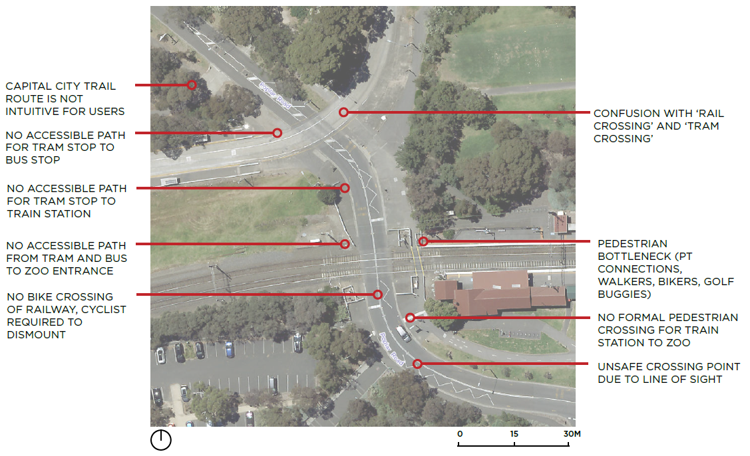
Figure 2 Royal Park Station precinct issues identification.
The closure of the railway line for a significant period for the project construction provides an opportunity to fix these issues. Investment through the project is warranted to offset the impact of the closure on public transport access to Melbourne Zoo and this area of Royal Park (as detailed in section 3.3).
The width of the rail corridor through Royal Park increases the fragmentation and divides the parklands. With the completion of the project, and future rail capacity planning, the amount of land retained for transport uses should be reviewed. This could allow for the simplification of leases and management arrangements.
Requirement
- A new-grade separated connection between Royal Park North and Royal Park South strictly in accordance with the Royal Park Master Plan and assessed heritage values of the Park, in a location and with a design to be determined in conjunction with the City of Melbourne.
- Reduce the footprint of the Upfield railway line within Royal Park and ensure infrastructure associated with the rail operations is not located within parkland.
- Improve and make safe the connections across the railway at Royal Park Station to better connect tram and bus stops with the Melbourne Zoo and separate the Capital City Trail from station access.
- Resolve land management arrangements along the rail corridor including transfer of VicTrack land to City of Melbourne for inclusion within the Parklands.

7.2 Improved Royal Park northern entrance
The Royal Park Master Plan notes that while the park landscape provides an important recreational asset and attractor for visitors, some areas around its perimeter lack detail and interest. The Master Plan recommends that a new entrance to Royal Park at the intersection of Park Street and Royal Parade be investigated, including the possible redevelopment of the former railway caretaker’s house to accommodate Park compatible uses and visitor amenities.
The existing substation at Park Street, the heritage railway structures, and the proximity of the tennis courts constrict the width of the Upfield shared use path and present a safety issue due to the restricted line of sight in this location.
The project presents a significant opportunity for the entrance into the park to be improved for cyclists and pedestrians at Park Street through a reconfigured area around the existing substation and heritage buildings at Park Street. The LXRP project team should also consider incorporating new informal recreation activities at Park Street, as delivered at other LXRP sites, for example basketball/netball rings and rebound walls.
Requirements
- Create safer and more inviting northern Royal Park entrance with improved shared path connections.
- Consider the redevelopment of the former gatekeeper’s cabin to accommodate Park compatible uses and visitor amenities.
- Consider incorporation of new informal recreation activities at Park Street.

7.3 Streets and Paths
Park Street is a local road which forms the border between City of Melbourne and Merri-bek City Council. It services Royal Park and local residential area with parking on the northern and southern side. There is a treed traffic median that creates a service road with parking on the northern side. The visual connection along Park Street is an important in connecting people with Royal Park.
The railway crossing at Park Street currently creates localised flooding issues due the limited stormwater pipe network and level changes around the crossing. The project must resolve these localised drainage issues at the rail corridor.
Park Street carries a significant amount of vehicle traffic for a local road. There is no right turn southbound on Sydney Road at Brunswick Road. This turning movement is permitted at Park Street allowing traffic to head west towards CityLink, Moonee Ponds or Flemington via Oak Street. Park Street provides a connection to the east into Princess Hill and Carlton North. A double right turn is provided from Park Street to travel south on Royal Parade.
The LXRP must consider the traffic movements on Park Street and Brunswick Road together in their analysis and design. With the removal of the level crossing from Brunswick Road there is an opportunity to have more of the through traffic remain on Brunswick Road. The LXRP must not encourage additional traffic onto Park Street.
City of Melbourne will not support any proposed long-term closure of Park Street as it would create several disadvantages for access to and around Royal Park. The overall width of the Park Street provides numerous opportunities to improve connection along Park Street for walking, cycling and greening. In addition to vehicle traffic, Park Street is an important walking and cycling link providing for east/west movements along the northern edge of Royal Park. Access from the Upfield shared use path to Royal Parade is via Park Street. Park Street also has cycle lanes east of Royal Parade connecting to schools, Capital City Trail and Princess Park. Therefore, highest bike volumes are on the section of Park Street east of the Upfield railway line.
At the level crossing the service lanes merge back into the main traffic lanes, limiting traffic in the service lanes. Between the Upfield railway corridor and Royal Parade, the service lane provides a safe cycling environment for eastbound travel. The westbound bike lane is not physically separated from traffic.
The Capital City Trail runs east–west through Princess Park under Royal Parade then along the Upfield railway line to Royal Park Station. The Upfield shared use path connects into this trail. There is also a shared path that connects The Avenue to the intersection of the Capital City Trail and Upfield shared path.
The project provides opportunities to improve cyclists and pedestrian facilities, to create smoother and safer journeys, with separate walking and cycling paths underneath the elevated railway. This includes a widened and straighter path connecting to the Capital City Trail in Royal Park with increased lighting, upgraded surfaces and clearer sight lines.
Currently, the level crossings on the Upfield railway line provide an indirect form of priority for walkers and cyclists on the Upfield shared use path by holding vehicle traffic while the boom gates are lowered. With the removal of these level crossings, it will be important to optimise traffic signals to ensure that users of the Upfield shared use path are not delayed.
Upon completion of the project, the Upfield shared use path will be upgraded in Merri-bek City Council area. It is anticipated that cycling into and out of the Melbourne municipality will increase, placing increased pressure on the shared foot and bicycle paths throughout Royal Park.
The project must upgrade any shared paths that it impacts to encourage and support increased active transport by providing:
- separate cycle and walk paths
- where separate cycle and walk paths are not feasible
- wider cycling path to accommodate future increased demand and reduced obstructions
- improved lighting and wayfinding
- increased active and passive surveillance
- reduced conflict points/lower stress intersections with other bike and pedestrian paths
- priority of the path over local road including at Park Street
- linked traffic signals along the path to provide a ‘green wave’ for cyclists
- a clear line of sight to prevent cyclist and pedestrian conflicts at the junction of Park Street.
Requirements
- Deliver an improved streetscape and transport outcomes on Park Street, with a safer connection between the Upfield shared use path and Royal Parade.
- Consider the traffic movements on Park Street and Brunswick Road together in the analysis and design. The LXRP must not encourage additional traffic onto Park Street.
- Optimise traffic signals to ensure users of the Upfield shared use path are prioritised over vehicle traffic at Park Street.
- Upgrade the Capital City Trail to improve safety and manage increased numbers of people riding bikes due to the upgrade of the Upfield shared use path in Brunswick.

7.4 Urban Design Guidelines
The LXRP has a consistent overarching design approach for all level crossing removal projects, known as the Urban Design Framework(UDF). The role of the framework is to guide the design and delivery of each project, outlining the quality, vision and aspirations for the projects.
While the UDF provides program wide guidance, LXRP also produces site specific Urban Design Guidelines (UDG) for each level crossing removal project, which are based on local and strategic context analysis. The UDG is being prepared for the Brunswick Level Crossing Removals Project following consultation with both City of Melbourne and Merri-bek City Council.
City of Melbourne and Merri-bek have both advocated for:
- Recognition and respect of the heritage character of the rail corridor and station buildings, with consultation to be undertaken with Heritage Victoria and the Traditional Owners regarding heritage elements.
- Review and integration of local heritage and landscape into any urban design and creative strategies for the project.
- Provision of direct, safe and separated pedestrian and cyclist north-south links, working with both City of Melbourne and Merri-bek City Council to identify connections through local streets.
- Ensuring that the abutment design and location improves the CPTED aspect of the Upfield shared use path adjacent to the Royal Park Tennis Club and increases the line of sight in this location through rationalisation of the infrastructure.
- Integration of useable spaces within the rail corridor that improve the activation of the spaces and the sense of place for the community.
- Ensuring a corridor wide CPTED assessment forms part of the overall site analysis and design development.
- A design and appropriate measures to deter vandalism and graffiti of the urban elements along the corridor.
- Creation of a wayfinding signage strategy integrated with the respective Council signage typologies.
- Minimising impacts to tree canopies along the corridor, with early assessment of existing vegetation and significant trees as part of the design process.
- The design of the southern abutment to be an integrated design which is sensitive to recreational and active transport users’ safety, with improved outcomes for Royal Park users.
- The design must be sensitive to visual impacts for users of Royal Park, with the use of vegetation for screening to integrate the structures into the open space corridor.
- Public lighting levels and sensors are appropriately designed and located to allow for both urban and high biodiversity environments, while also improving the CPTED conditions around Royal Park.
- Assessment of the overshadowing from the elevated design to inform the viability of open space interfaces.
- A shade analysis of the corridor to inform the landscape design, selection of plant material and locations of public realm nodes. Ensure proposed plant species are appropriate to Royal Park's high biodiversity and in line with City of Melbourne’s Urban Nature Planting Guide and the Royal Park Master Plan.
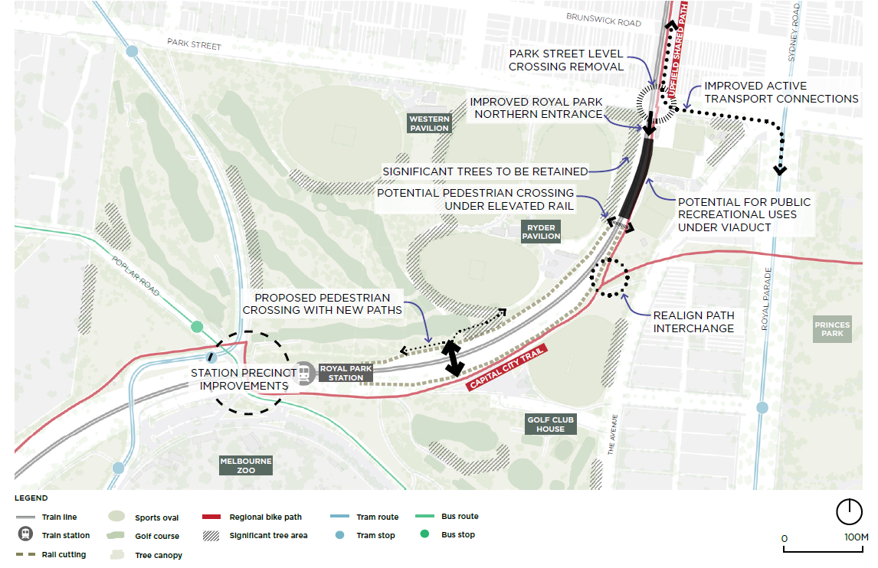
Figure 3 Summary of City of Melbourne Design requirements
Requirements
- The project adopts strong and clear Urban Design Guidelines and continues to work with residents, business and Councils to integrate this guidance into the final design.
- No net reduction in area of Royal Park in accordance with City of Melbourne Parks Policy, with the reduction test inclusive of all expanded paved area ancillary to the rail project proper.
- Undertake a shade analysis of the viaduct to inform the viaduct placement and design to minimise impact on the parklands as well as inform the landscape design.
- A 3D model of the area of Royal Park affected by the LXRP should be developed to understand the visual impacts and test mitigation strategies.
- Minimise negative impacts of the elevated rail line (viaduct) including overshadowing and interruption of vistas from within or to Royal Park. Overshadowing and visual impacts of the infrastructure should be minimised through the size and height of the structure, reduce the clearance over Park Street and reduce the number of structures above the rail track. Reducing the visual impact of the viaduct, structural pillars and embankments by using landscaping and planting to screen the railway.
- Protect and preserve heritage assets, including the Park Street Gatekeeper’s Cabin and the gates.
- Tell the story of Aboriginal Cultural Heritage and the Wurundjeri Woi-wurrung and Bunurong Boom Wurrung peoples of the Eastern Kulin as Traditional Owners of the land.
- Ensure lighting levels, noise and vibration impacts of the elevated rail line and train operations are appropriately designed, located and managed considering both the urban and high biodiversity surroundings.

7.5 City of Melbourne Design and Construction Management Standards
Any infrastructure or assets constructed as part of the project that are to be returned to the City of Melbourne must be constructed to our standards and digital information about the assets must be provided to Council upon their completion. Inspections prior to handover are important in ensuring the quality and maintainability of returned assets.
City of Melbourne will not accept assets or landscaped areas where there has not been continuous and collaborative involvement by City of Melbourne from design through to construction and completion. Key reference documents are:
- Design and Construction Standards
- Operating Procedure Bluestone in Melbourne's streets and lanes
- Stormwater Drainage Design Guidelines
- Groundwater Management Guidelines
- Engineering Standard Drawings
- Tree Protection Policy
- Lighting Guidelines
- Requirements for as-built drawings
Requirements
- The Brunswick LXRP project team must use City of Melbourne design standards and guidelines for all returned assets. Prior to project design completion, LXRP must confirm the latest applicable standards and guidelines and agree to the application of such.

https://heritagecouncil.vic.gov.au/wp-content/uploads/2014/09/Heritage-Registration-Report-Royal-Park.pdf
https://vhd.heritagecouncil.vic.gov.au/places/56083
https://www.melbourne.vic.gov.au/SiteCollectionDocuments/masterplan-royal-park.pdf
https://www.melbourne.vic.gov.au/SiteCollectionDocuments/masterplan-royal-park.pdf
https://heritagecouncil.vic.gov.au/wp-content/uploads/2014/09/Heritage-Registration-Report-Royal-Park.pdf
https://www.melbourne.vic.gov.au/sitecollectiondocuments/open-space-strategy.pdf
https://heritagecouncil.vic.gov.au/wp-content/uploads/2014/09/Heritage-Registration-Report-Royal-Park.pdf
https://www.melbourne.vic.gov.au/sitecollectiondocuments/nature-in-the-city-strategy.pdf
https://www.melbourne.vic.gov.au/SiteCollectionDocuments/transport-strategy-2030-city-of-melbourne.pdf
https://www.melbourne.vic.gov.au/SiteCollectionDocuments/nature-in-the-city-strategy.pdf
https://www.melbourne.vic.gov.au/SiteCollectionDocuments/policies_parks.pdf
https://www.melbourne.vic.gov.au/community/greening-the-city/urban-forest/Pages/urban-forest-strategy.aspx
https://www.melbourne.vic.gov.au/SiteCollectionDocuments/ufpp-parkville-precinct.pdf
https://www.melbourne.vic.gov.au/community/parks-open-spaces/policies-plans/Pages/open-space-strategy.aspx
https://aboriginal-map.melbourne.vic.gov.au/welcome
https://www.melbourne.vic.gov.au/arts-and-culture/strategies-support/Pages/public-art-framework.aspx
https://www.melbourne.vic.gov.au/residents/home-neighbourhood/street-lighting/Pages/public-lighting-strategy.aspx
https://www.melbourne.vic.gov.au/community/greening-the-city/urban-nature/Pages/nature-in-the-city-strategy.aspx
https://www.melbourne.vic.gov.au/community/greening-the-city/urban-forest/Pages/urban-forest-strategy.aspx
https://www.melbourne.vic.gov.au/SiteCollectionDocuments/tree-policy-2021.pdf
https://www.melbourne.vic.gov.au/building-and-development/planning-and-building-services/construction-development/legislation-guidelines/Pages/code-of-practice-building-construction.aspx
https://bigbuild.vic.gov.au/__data/assets/pdf_file/0011/635771/LXRP-Urban-Design-Framework-v5-October-2020.pdf
https://www.melbourne.vic.gov.au/SiteCollectionDocuments/policies_parks.pdf
https://www.melbourne.vic.gov.au/building-and-development/standards-specifications/Pages/design-standards.aspx
https://www.melbourne.vic.gov.au/SiteCollectionDocuments/operating-procedure-bluestone.pdf
https://www.melbourne.vic.gov.au/SiteCollectionDocuments/stormwater-drainage-design-guidelines.pdf
https://www.melbourne.vic.gov.au/SiteCollectionDocuments/groundwater-management-guidelines.pdf
https://www.melbourne.vic.gov.au/building-and-development/standards-specifications/Pages/engineering-standard-drawings.aspx
https://www.melbourne.vic.gov.au/community/greening-the-city/tree-protection-management/pages/tree-protection-policy.aspx
https://www.melbourne.vic.gov.au/SiteCollectionDocuments/lighting-guidelines.pdf
https://www.melbourne.vic.gov.au/building-and-development/standards-specifications/Pages/requirements-as-built-drawings.aspx

