LibraryLink 2 (LLV2) Guide

1. Access LibraryLink 2 at https://llv2.vdxhost.com/
Enter your library barcode number and password. Select City of Melbourne Libraries from the drop-down menu. Click ‘Login’.
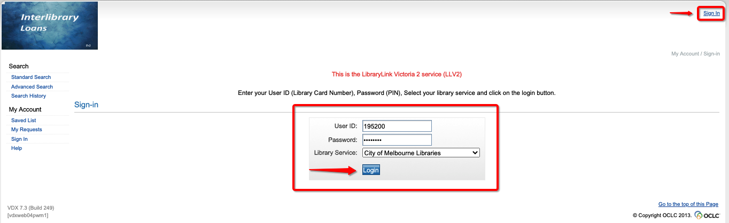

2. Searching
Enter search terms and choose search profile
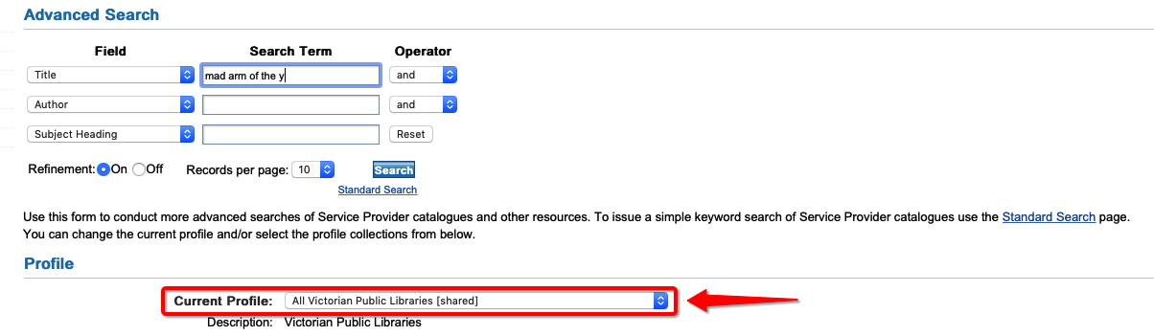
*Note: The search profile defaults to “All Victorian Public Libraries [shared]”, which searches live data, so is most accurate.

If you don’t get results with the Victorian Public Libraries search profile, you can change the search profile to “All Victorian Public Libraries and LA [shared]” in order to include item holdings at interstate libraries and academic libraries. Please note that this data is less accurate, and academic and some interstate libraries charge for interlibrary loans.

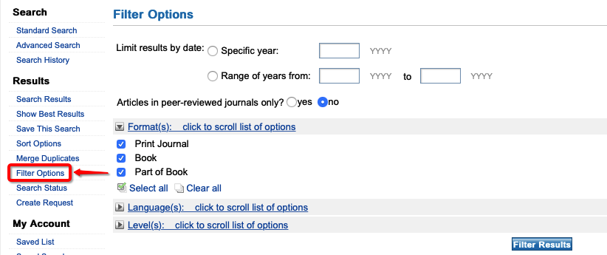
3. Returned search results

You can filter your search results by date, format, language or level by clicking “Filter options” on the left hand menu.

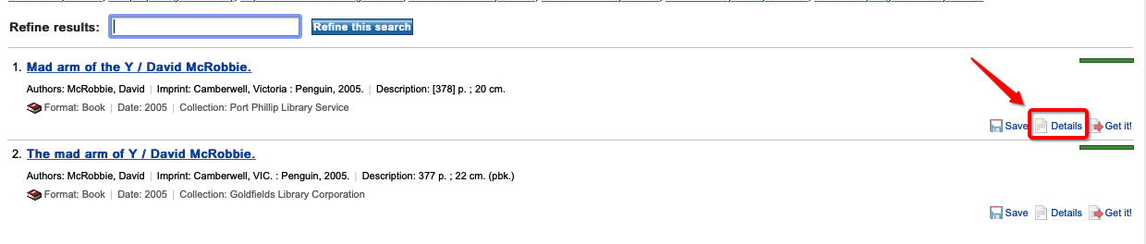
Click “Details” in the title you would like to view

Check the record details to make sure this is the item you would like to request.
Click “Get it” at the top right of the record details screen
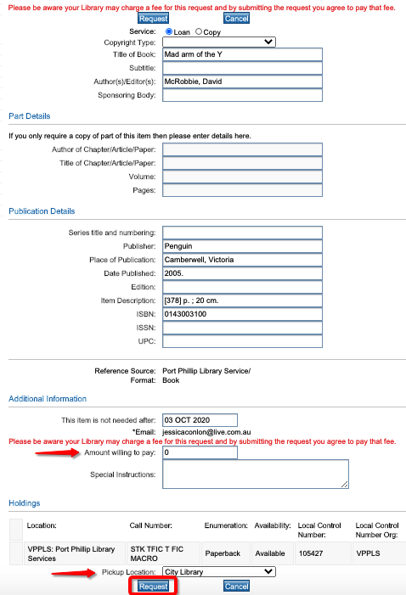

4. Finalise request

Publication details will be pre-filled on the request form, check that they are correct.
If you are willing to pay, enter $30.30 into the “amount willing to pay” field, otherwise leave blank. Select your pick up location.
Click “Request”.

5. Requesting an article or chapter
To request a journal article or book chapter, search for the book or journal. On the request form, click ‘Copy’ and fill in part details of the journal article or book chapter under ‘Part Details’.

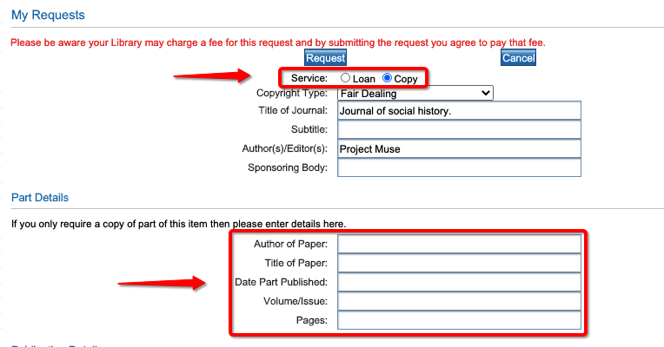

6. Monitoring requests
Monitor the progress of your requests by clicking ‘My Requests’ on the left hand menu. To cancel a request click ‘Cancel’. Untick ‘Show everything’ to see current results only.

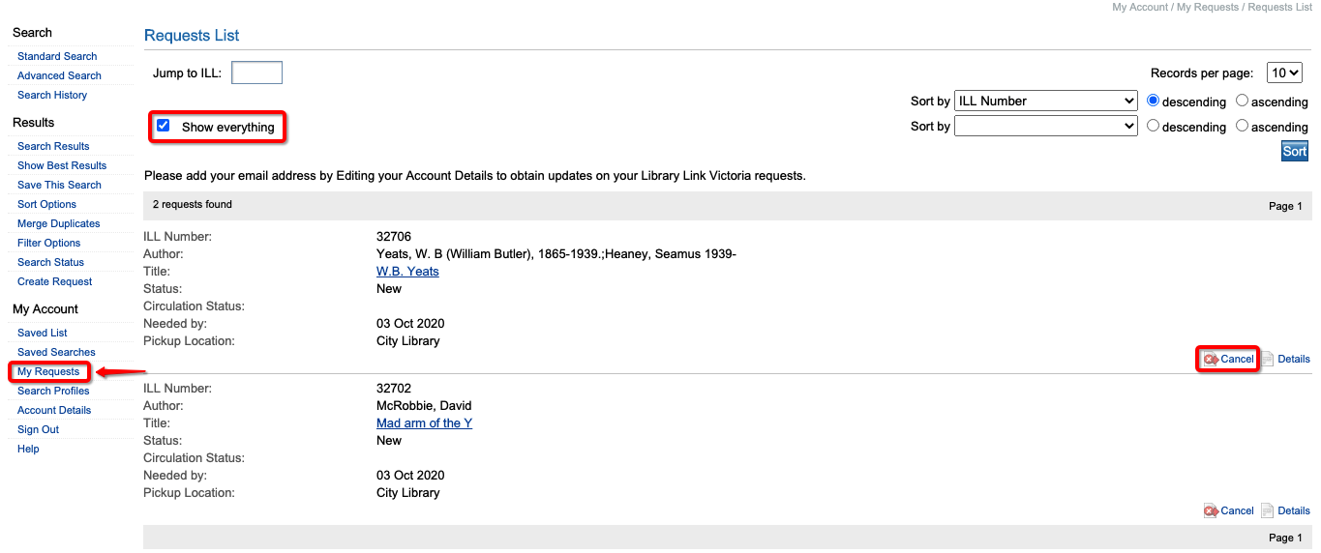

Status meanings:
- New – your request is awaiting approval by City of Melbourne Libraries interlibrary loans staff
- Pending – your request is being considered by a potential supplying library
- Shipped – the item has been sent by a supplying library
- Received – the item has arrived at City of Melbourne Libraries
- Completed : Returned – the item has been returned to the supplying library

